Introduction

(Cory Morewitz)

Setup

Login

Student

Select Reading from library (Ali Albattah)

Select Mode Colored paragraph (Ali Albattah)

Student

Slashed Text (Andrew Chverchko)

Slashed Exceptions (Andrew Chverchko)

Slash Player (Andrew Chverchko)

Instructor

General

View the Document Library (James Ward)

Open Document (James Ward)

Edit Document (James Ward)

Add Document to the Library (James Ward)

Remove Document from the Library (James Ward)

Exception List (Erich O’Saben)

Managing the Exception List (Erich O’Saben)

View Class List (Charles Stafford)

Add Student User (Charles Stafford)

Removing a Student User(Fredrick Murry)

Create Class (Justin Bennett)

Administrator

Admin Log In (Francia Molina)

Add Instructor User (Francia Molina)

Remove Instructor User (Francia Molina)

View Instructor List (Francia Molina)

Troubleshooting(Artem Fisan)

Conclusion

Log out (Mohammed Alabdullatif)

Contact Us

# Introduction

# (Cory Morewitz)

Et tu Brute? Welcome to CESR! The Color Enhanced Slash Reader is the latest and greatest way to learn parts of speech and increase reading speed and comprehension. With our easy to use, comprehensive web application, you’ll find it impossible not to improve your grammar, reading speed, and comprehension.

All over the country, English as a Second Language students are struggling to learn different parts of speech and increase their reading speed and comprehension. This problem is epidemic. The majority of ESL students read below the normal level, and because of this, end up getting held back.

Current part of speech taggers only allow for display, you can’t change the tag if it’s incorrect. CESR, making use of our innovative COLR module, solves this problem by providing edit functionality; no longer will you go through life thinking something is a noun when it’s not! Breeze through viewing different parts of speech one at a time or mark them all and check your knowledge.

CESR’s Slash module breaks text into thought groups which then allows you to read them at your leisure or feed them into the Slash Reader. Other speed readers teach you to read word by word. That may increase your reading speed, but all that you’re accomplishing is finishing your reading more quickly so you can start over, because your comprehension stays low. CESR teaches you to read in chunks, this increases reading speed AND comprehension.

Instructors, you’ll love making use of the edit and save functionality. Instead of tediously writing sentences on the boards and wasting time identifying parts of speech, then starting over for the next class, you can mark up a document, save it, and use it for every class! You can devote more time to teaching your students instead of just setting up to do so. It saves time, and allows for reusability through the years. CESR’s Slash module will allow you to enhance your student’s reading ability by teaching the slash reading concept, while the Slash Reader module will allow you to track your student’s progress through the semester.

Students, science has shown that color can help increase memorization and comprehension. Using the COLR module, you can begin to really grasp different parts of speech and your recognition of them. The Slash Reader module will allow your reading speed and comprehension to grow by leaps and bounds. CESR will not only increase your reading capabilities, it will also increase the enjoyment you get from reading. CESR will make reading fun again.

To begin your journey, simply visit<http://esl-clash.cs.odu.edu/>, and render unto CESR the things that are CESR’S! Or, you know, just type in the user name and password you’ve been provided. From there, follow the easy steps laid out below depending on your account type and enjoy!

# 

# 

# Setup

### Login

--------------------------------------------------------------------------------------------------------------

This section of the user manual provides step by step instructions for logging into the CESR system. CESR has three levels of user access available: student, instructor and administrator. Students shall login using only the user credentials provided to them in order for statistics pertaining to their reading performance to be logged. Instructions pertaining to functions for each level of user access are located in subsequent sections per the table of contents. Let’s begin!

1. Open your web-browser and type in the URL bar <http://esl-clash.cs.odu.edu/>

An example of the Login Page is shown in the figure below.

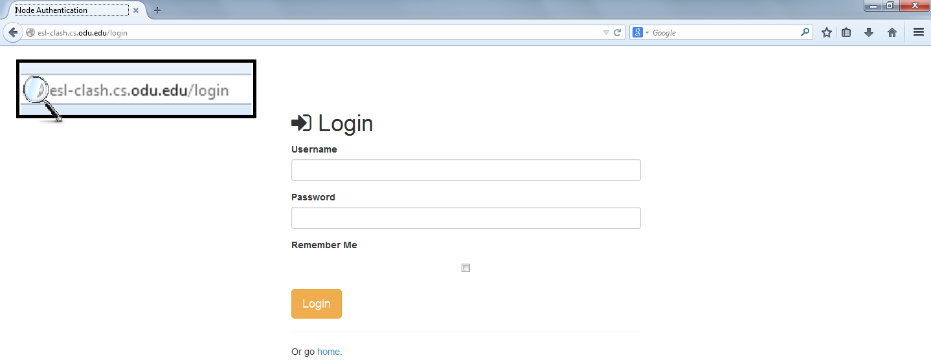

1. Enter your username and password then click login.
2. Follow the instructions throughout the remainder of this manual as applicable to your user accounts access level and enjoy using CESR!
3. Remember to logout when you’re finished by following the instructions in the Conclusion section of this manual.

# Student

### Select Reading from library (Ali Albattah)

--------------------------------------------------------------------------------------------------------------

The “Student View” will load

An example of the “Student View” is shown in the figure below.

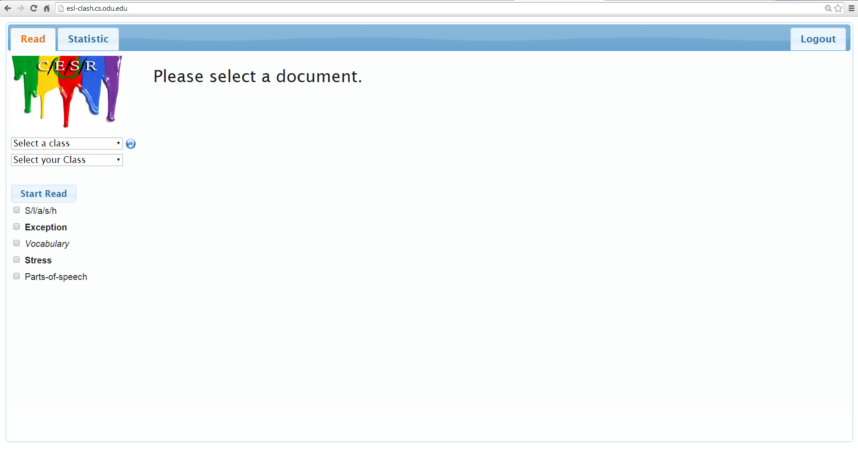

1. Select Reading from library
2. From Drop Down Menu, Select a class.

An example of clicking on the “my class” is shown in the figure below.

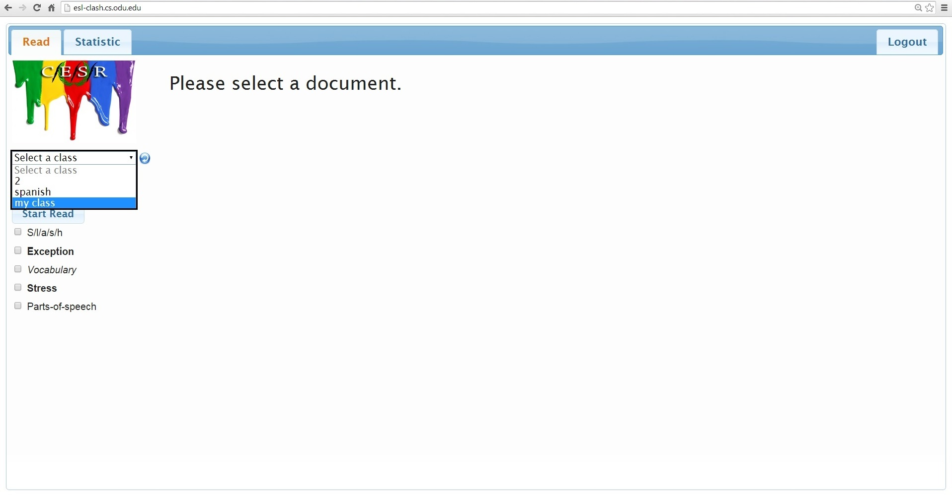

b. From Drop Down Menu, Select a File.

An example of clicking on the “CaesarFixed” is shown in the figure below.

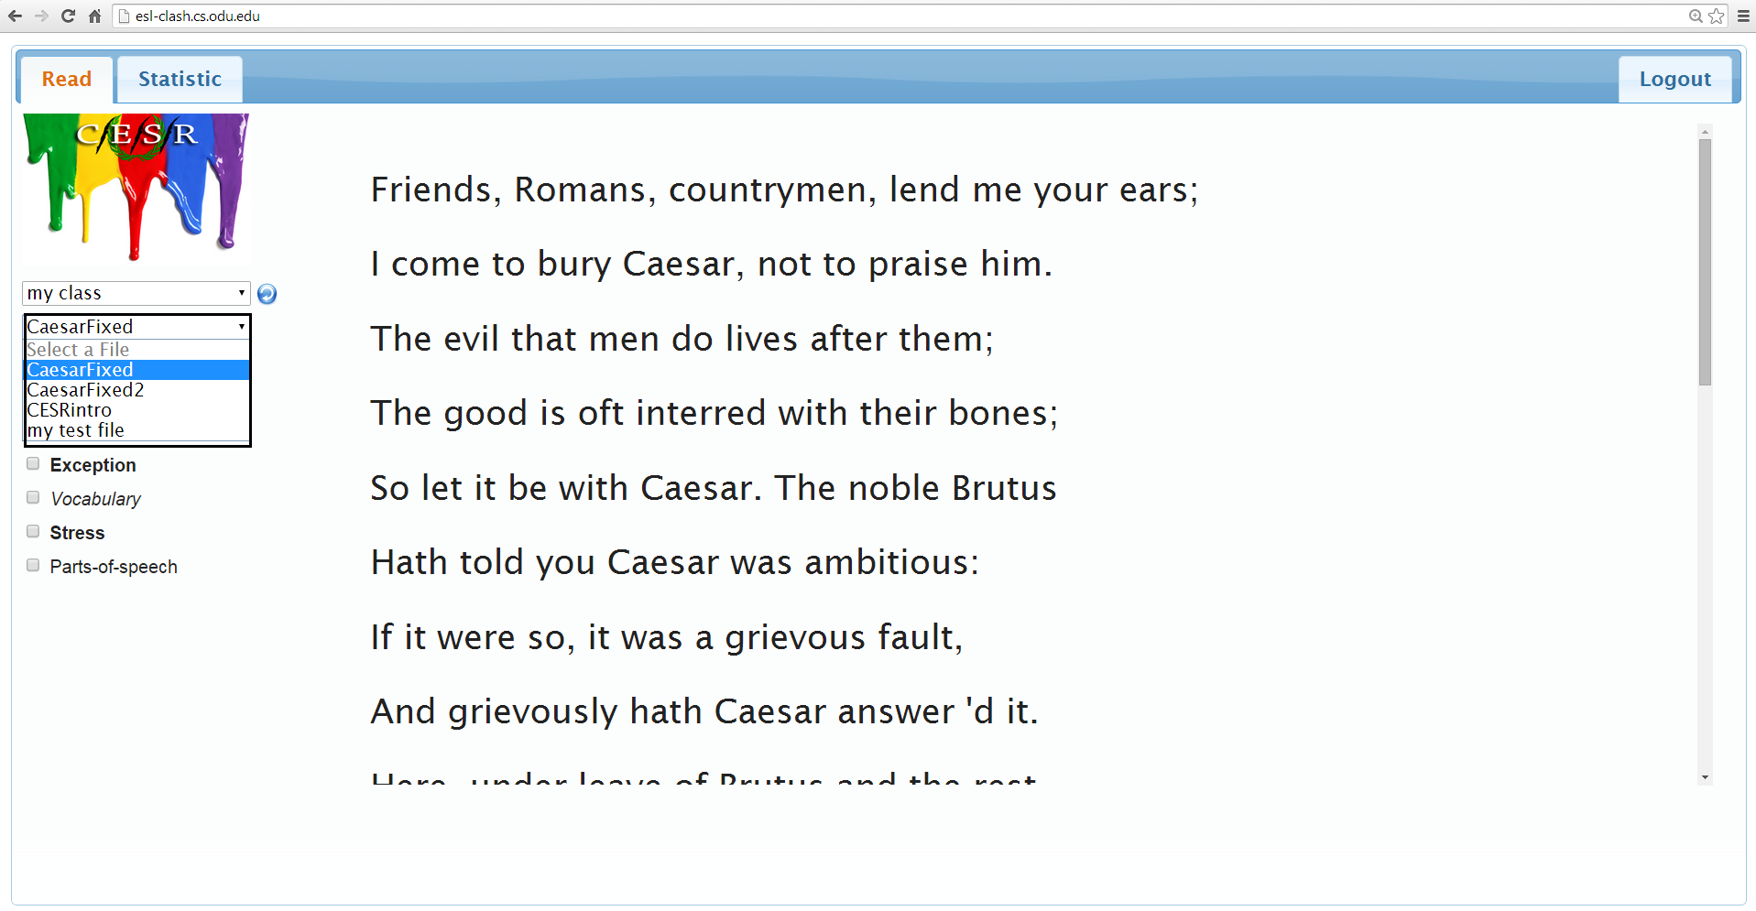

### Select Mode Colored paragraph (Ali Albattah)

-------------------------------------------------------------------------------------------------------------

2. Select Mode Colored paragraph

Student toggles “Part-of-speech” to select Mode Colored paragraph to color every part of speech with a unique color.

An example of toggling on the “Part-of-speech” is shown in the figure below.

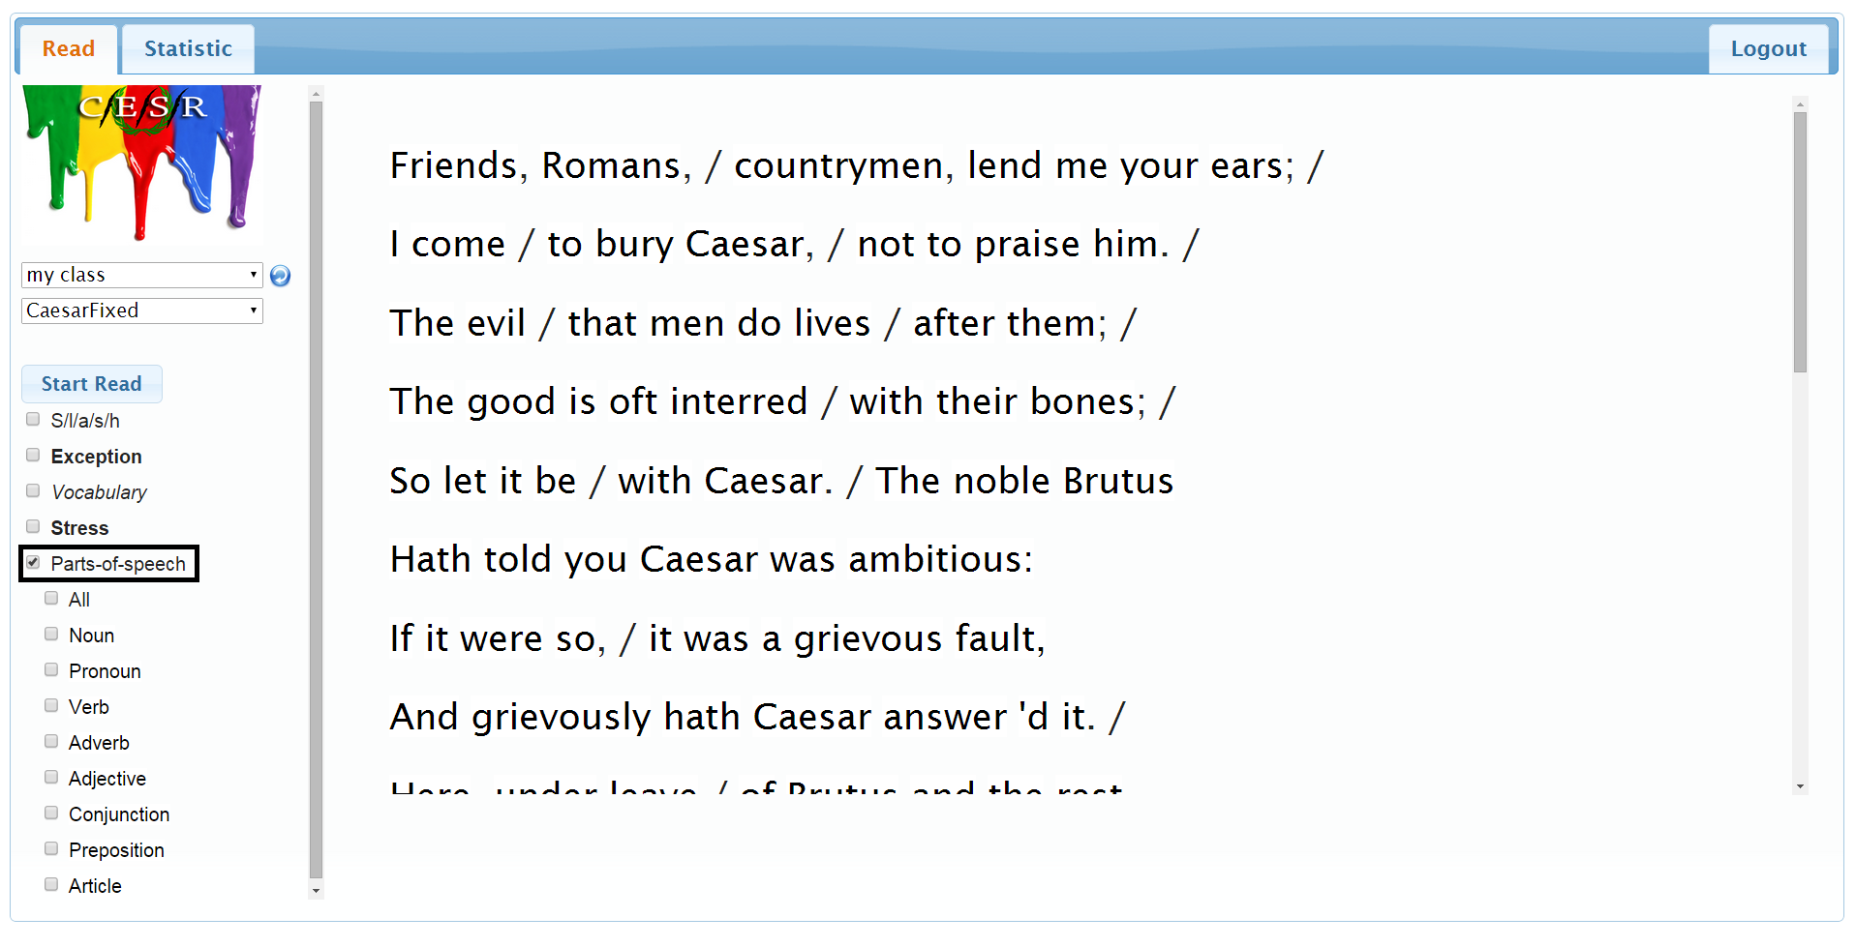

1. Student toggles “Noun” to color all the nouns.

An example of toggling on the “Noun” is shown in the figure below.

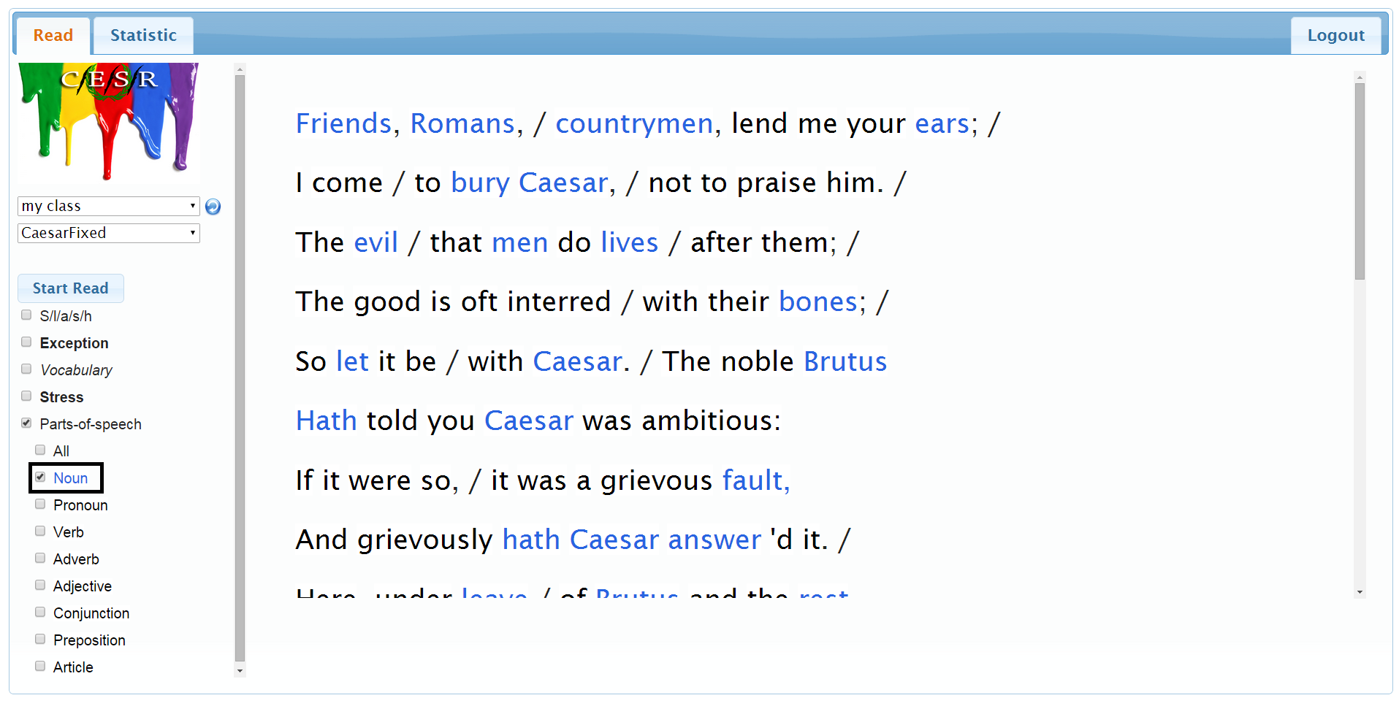

b. Student toggles “Noun and Adverb” to color all the nouns and adverbs.

An example of toggling on the “Noun and adverb” is shown in the figure below.

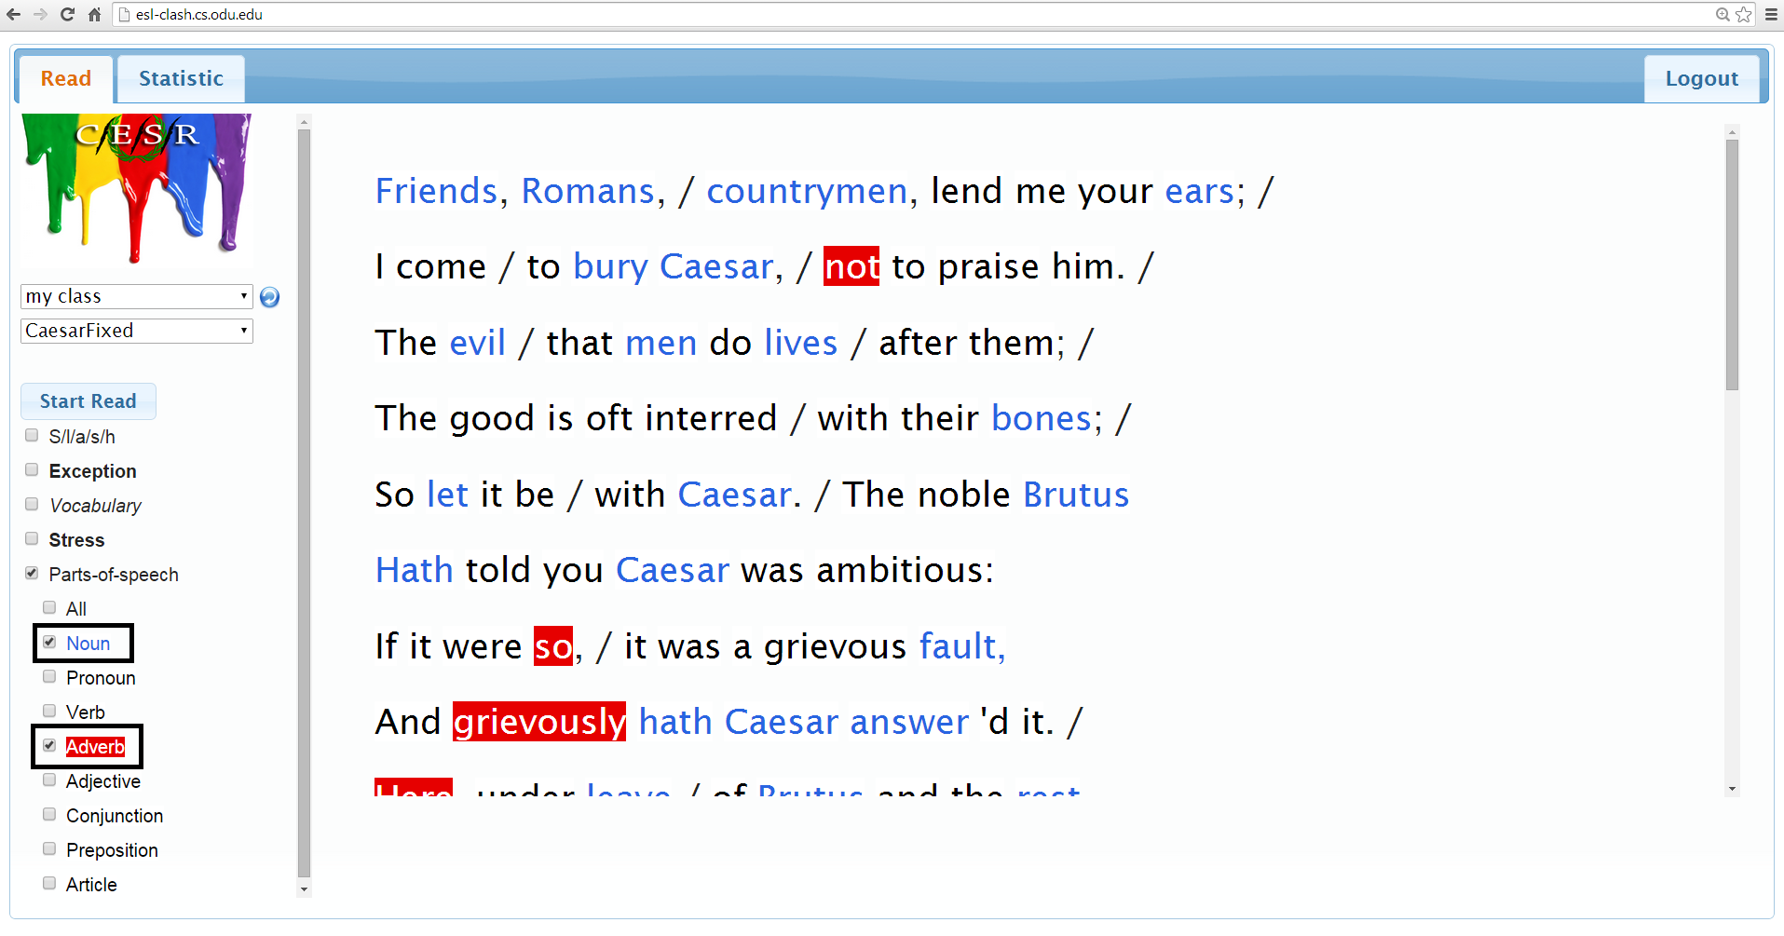

c. Student toggles “Noun, Adverb, and Adjective” to color all the nouns, adverbs, and adjectives.

An example of toggling on the “Noun, Adverb, and Adjective” is shown in the figure below.

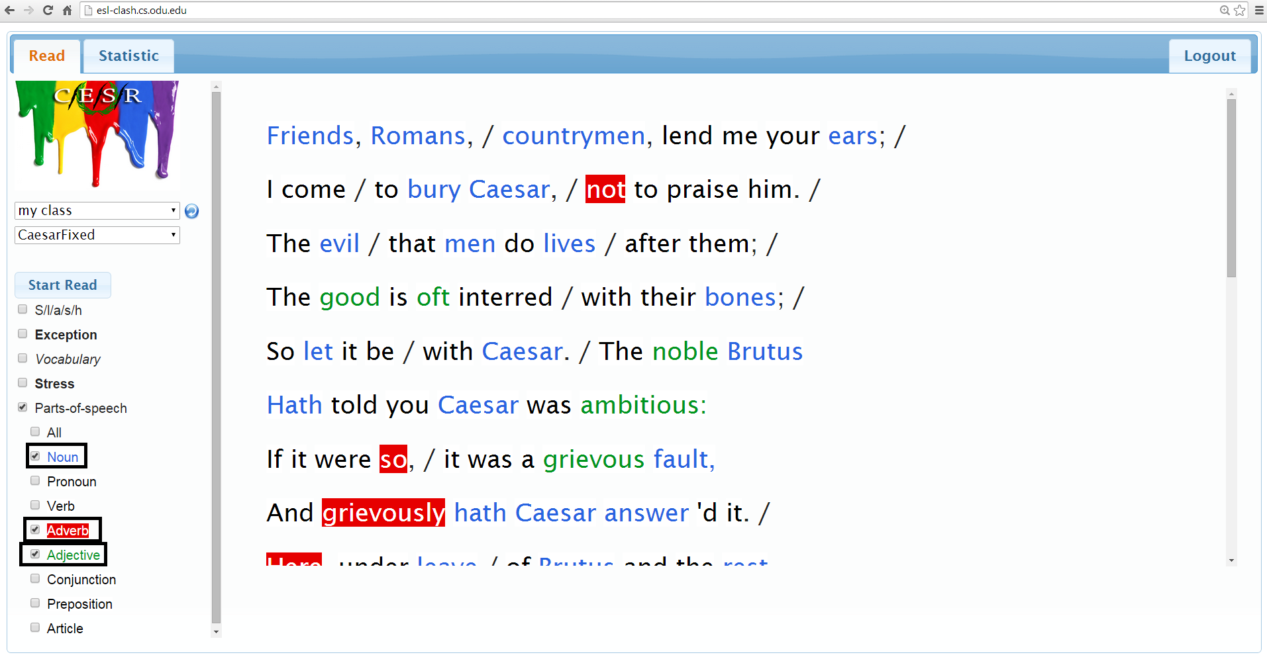

d. Student toggles “All” to color all the part of speech.

An example of toggling on the “All” is shown in the figure below.

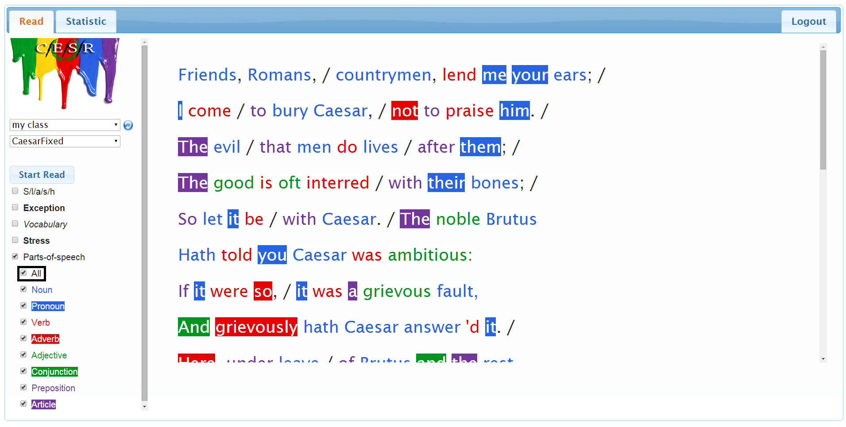

# Student

### Slashed Text (Andrew Chverchko)

--------------------------------------------------------------------------------------------------------------

1. Type in the URL bar http://esl-clash.cs.odu.edu/

2. Login under a student account

3. Select the upload tab

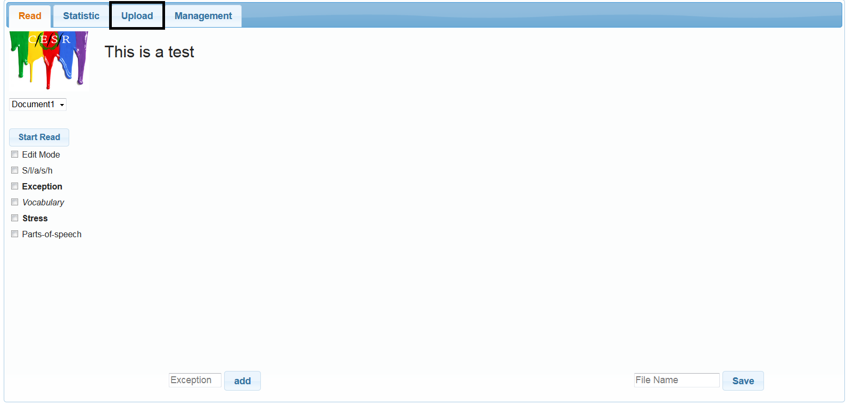

4. Select either the text field to input a sentence or select the file upload button called “Browse”

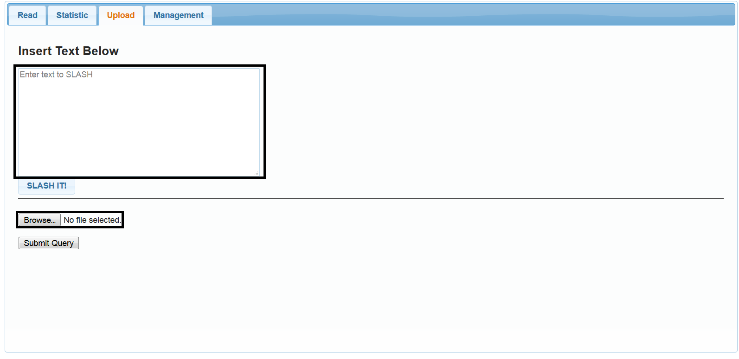

4a. if you chose the text field, then press the “Slash IT!” button

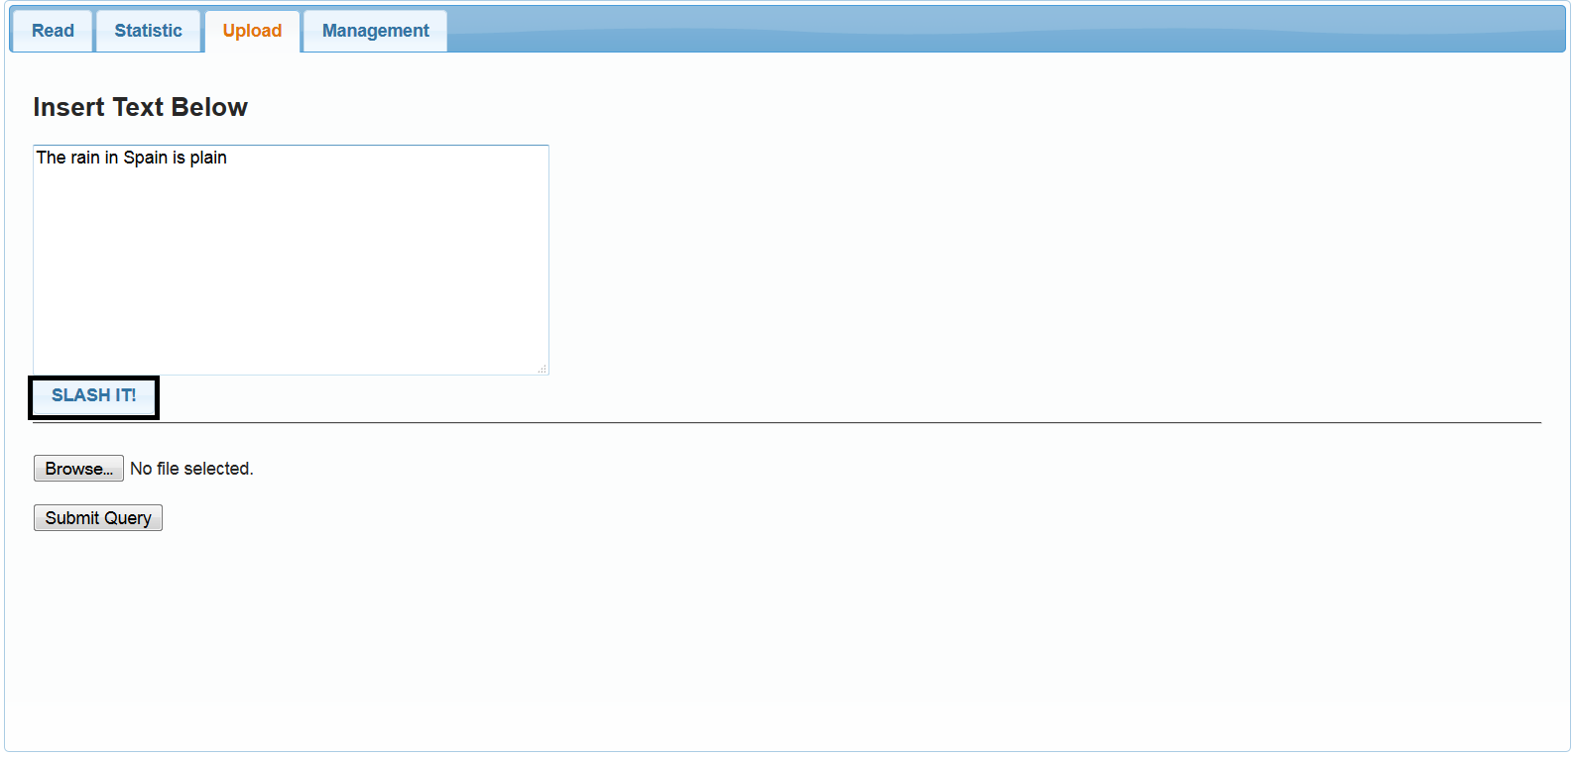

4b.If you choose the “Browse” button, Select the filename you want to use

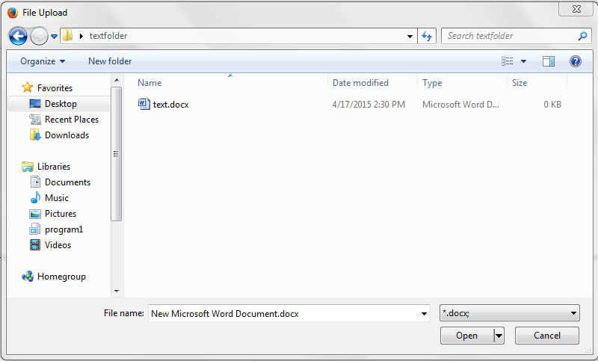

4b1. After you select the file, press the “Submit Query” button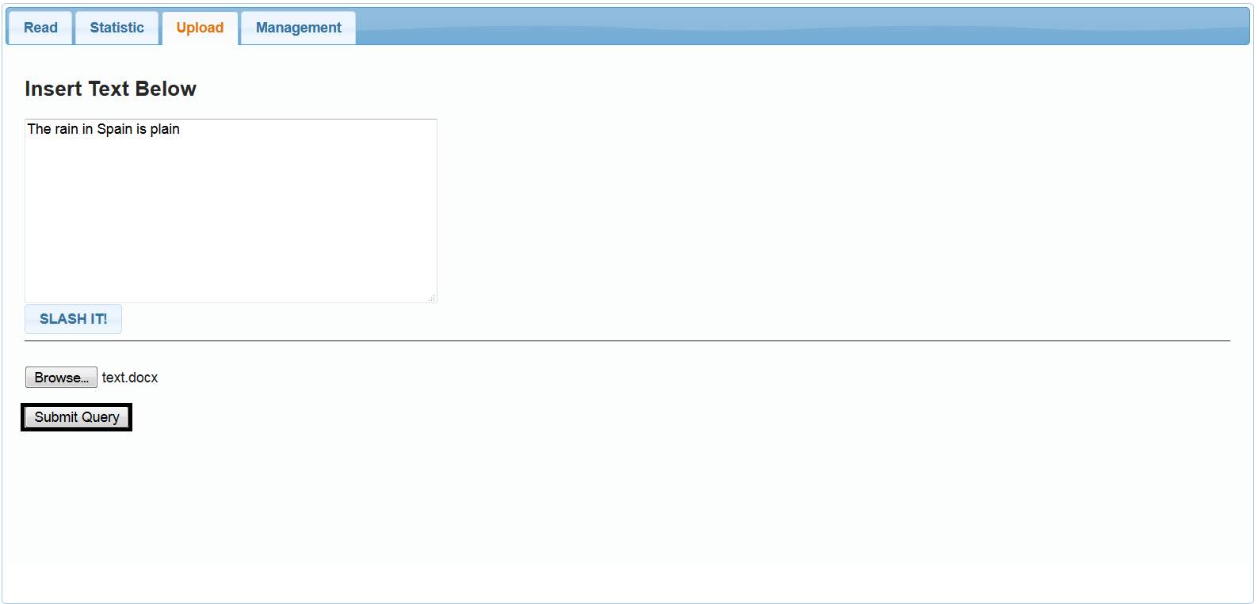

5. To view the slashed version of the text, you select the “S/l/a/s/h” checkbox

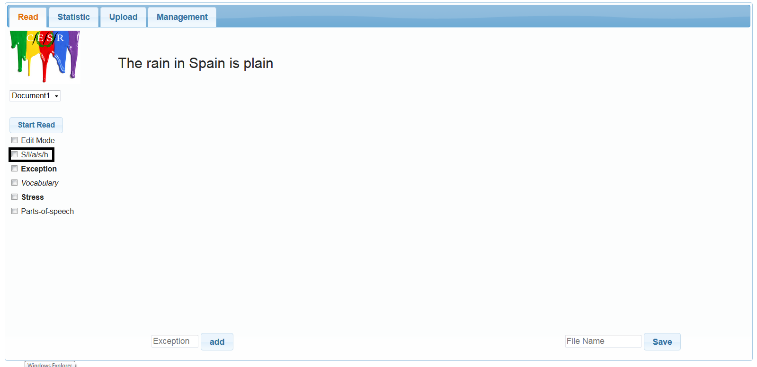

6. Slashes can be seen inside the text

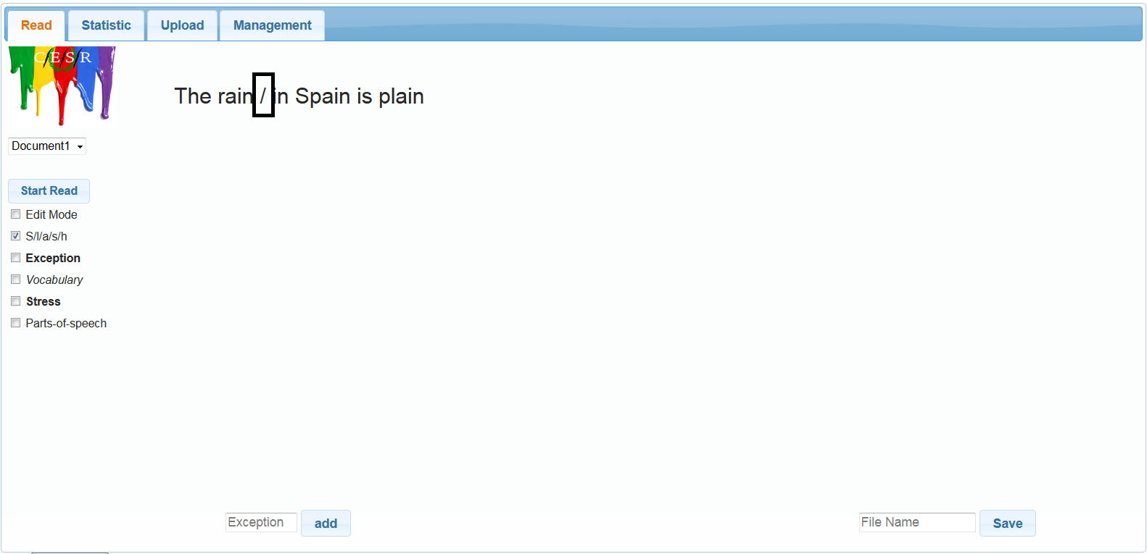

### Slashed Exceptions (Andrew Chverchko)

--------------------------------------------------------------------------------------------------------------

1. Perform steps 1-6 of preceding Slashed Text

2. Click the “Exception” checkbox to view the exceptions

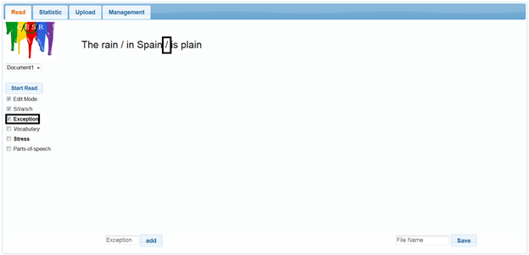

### Slash Reader (Andrew Chverchko)

--------------------------------------------------------------------------------------------------------------

1. Repeat steps 1-4 of Slashed text with any account type

2.Press the “Start Read” button

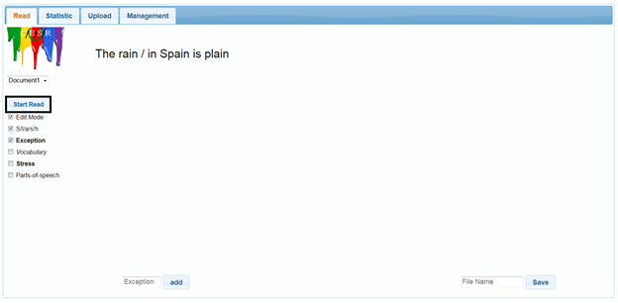

3. The text will display and automatically play the text

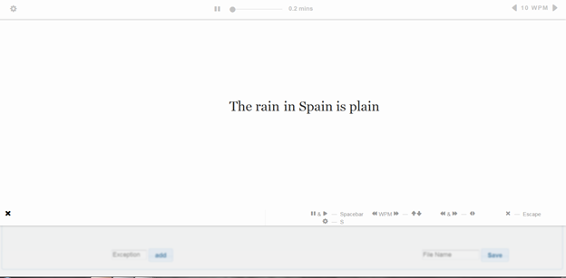

4. The Slash player has a number of controls explained in the chart below

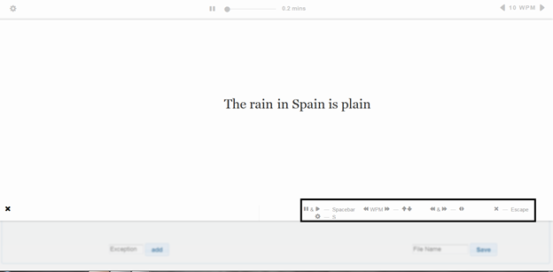

|  |  |
| --- | --- |
| Function: | Button: |
| Play/Pause | Spacebar |
| Speed increase/decrease | “Up” and “Down” arrow buttons |
| move forward/backward in the text | “Left” and “Right” arrow buttons |
| Settings | “S” button |
| Exit | “Escape” or “ESC” button |

# Instructor

### General

--------------------------------------------------------------------------------------------------------------

This section of the user manual provides step by step instructions for tasks available to instructor level accounts. To begin login to your instructor account per the instructions in the Setup section.

### View the Document Library (James Ward)

--------------------------------------------------------------------------------------------------------------

There are two paths an instructor can take to view the documents in the library. Both paths are documented herein. The first path is similar to the one used by student level account users and is performed from the Read tab. The other path is via the Management tab and its instructions are covered below the first.

Option 1 To view the documents library.

1. Upon login click the blue circular refresh button to the right of the “Load your class” drop down.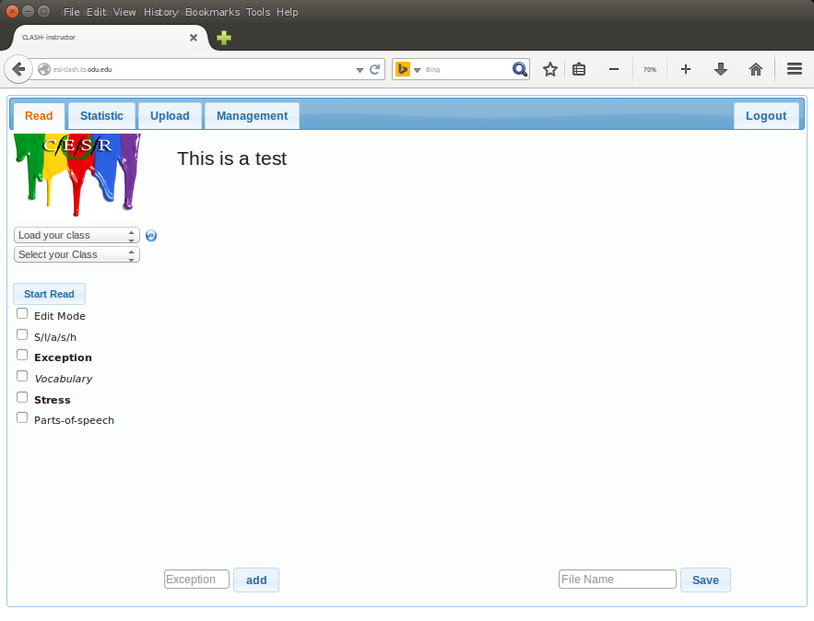
2. The “Load your class” drop down will rename to “Select a class” drop down.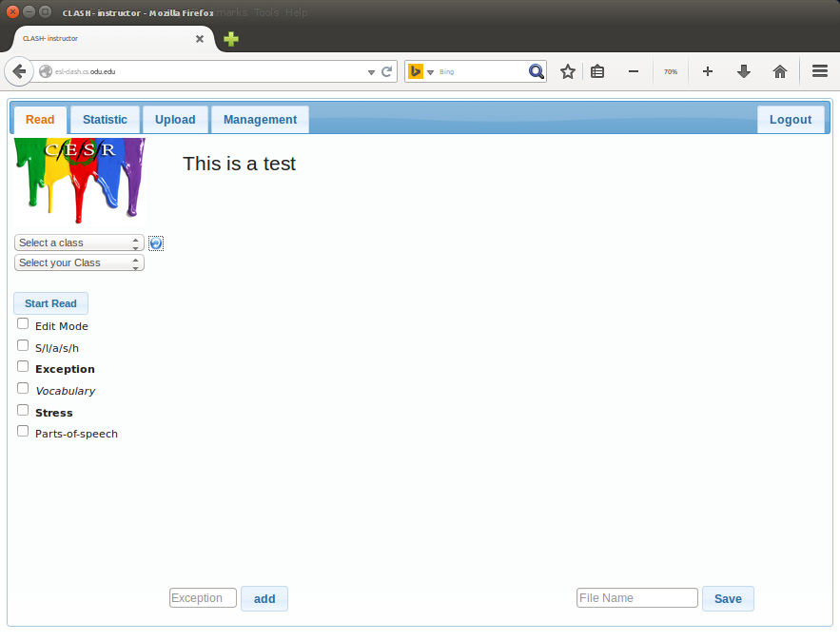
3. Click the “Select a class” drop down and choose a class.
4. The “Select a class” drop down will rename to a drop down showing the class you chose.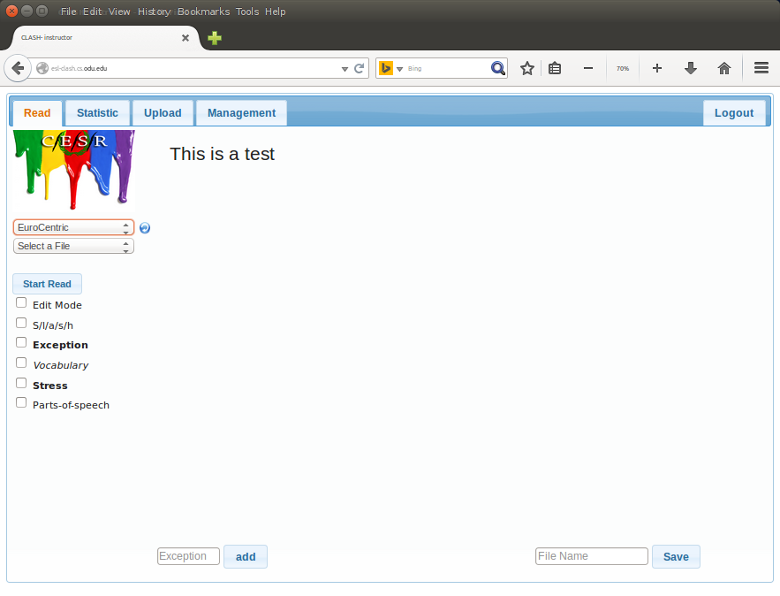
5. Next click the drop down for select a file. This list is the documents library.

Option 2 To view the documents library.

1. Click on the management tab.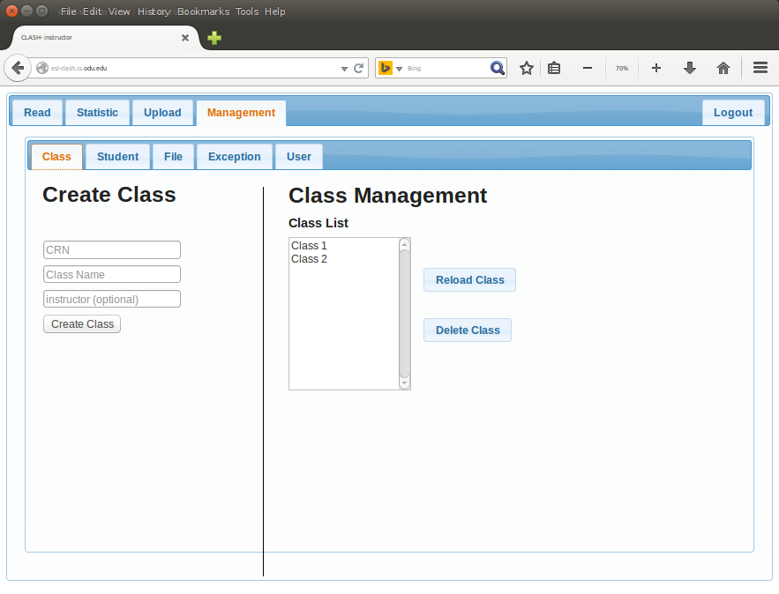
2. Click on the File sub-tab.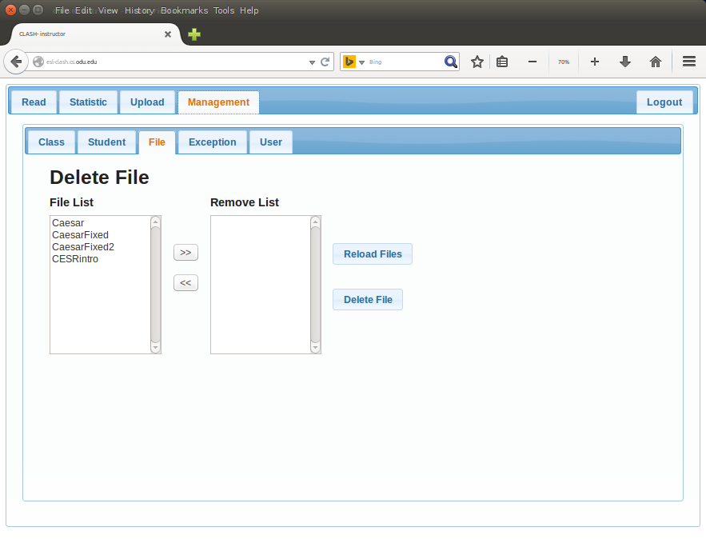

### Open Document (James Ward)

--------------------------------------------------------------------------------------------------------------

1. Click on the Read tab.
2. To open a document follow the instructions above for “Option 1 To view the documents library”. At step 5 click on a document name to read or edit that document.

### Edit Document (James Ward)

--------------------------------------------------------------------------------------------------------------

Note - the editing system in CESR is functional but persnickety (like Canadians). To successfully edit documents in CESR you may need to toggle checkboxes off then on again if they have been previously selected.

1. To Edit a document in the library first open the document per the Open Document steps above.
2. Next click the check boxes for “S/l/a/s/h” and “Parts-of-speech”.
3. Click the checkbox for “All”
4. Click the checkbox for “Edit Mode”.
5. Review the document for errors. Where an error has been made right click the word and a drop down opens allowing changes to be made.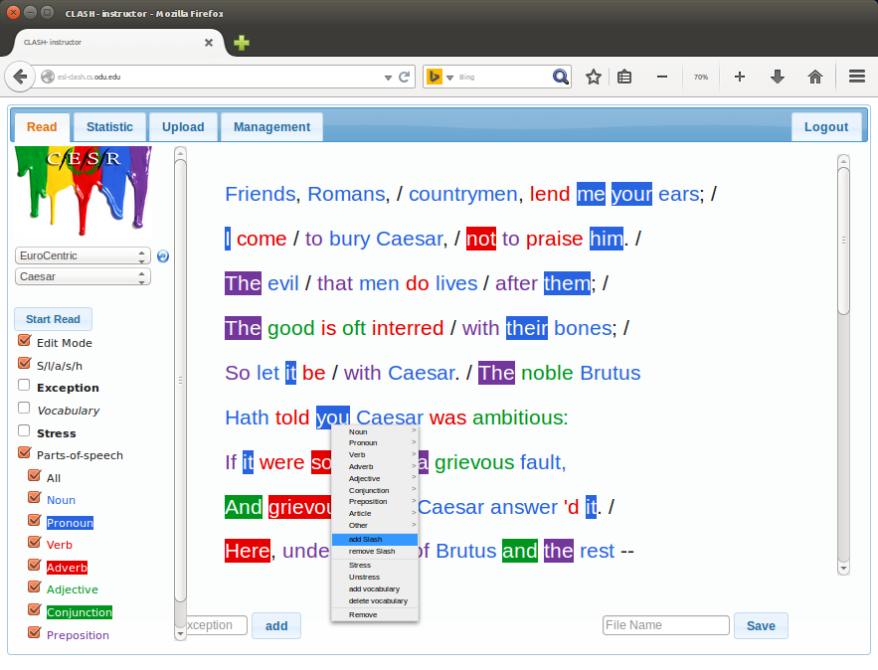
6. After changes are made enter a new document name and click save.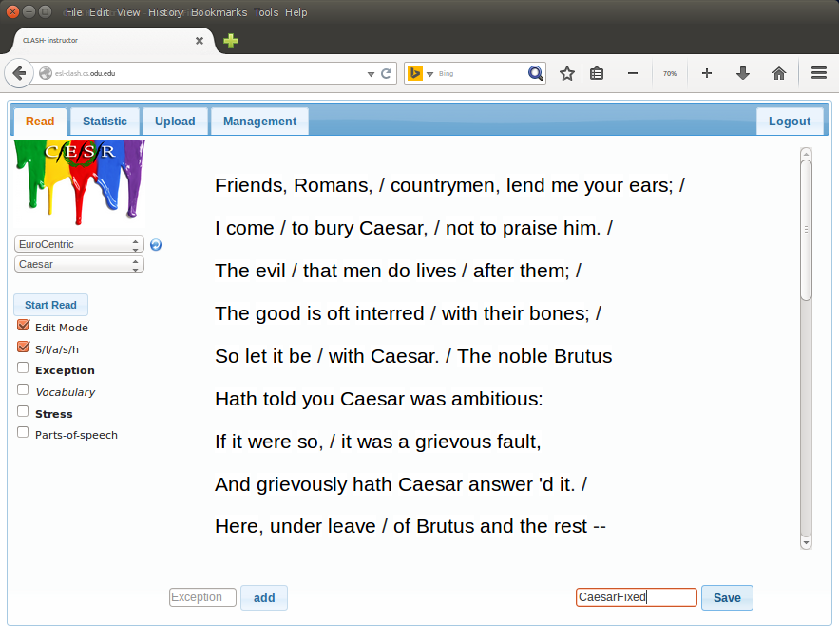

### Add Document to the Library (James Ward)

--------------------------------------------------------------------------------------------------------------

1. Click the Upload tab
2. Either click in the text field to type of paste text, or select the file upload button called “Browse”
3. If you chose the text field, enter your text by typing or pasting then press the “Slash IT!” button.
4. If you chose the “Browse” button, Select the filename you want to use and click Open. Note only .docx files are accepted in this version of the software. 
5. After you select the file, press the “Submit Query” button

### Remove Document from the Library (James Ward)

--------------------------------------------------------------------------------------------------------------

There are times where an instructor may wish to test the flow of the slash player based on their own edits, doing so requires saving a second copy of the document or manually undoing any changes to it if they are deemed unacceptable. If a second copy is no longer needed or is removed from the curriculum the option exist to remove it from the library. Removing Documents from the library is very simple.

1. Perform steps 1 and 2 of “Option 2 To view the documents library”.
2. Select the file(s) to be removed.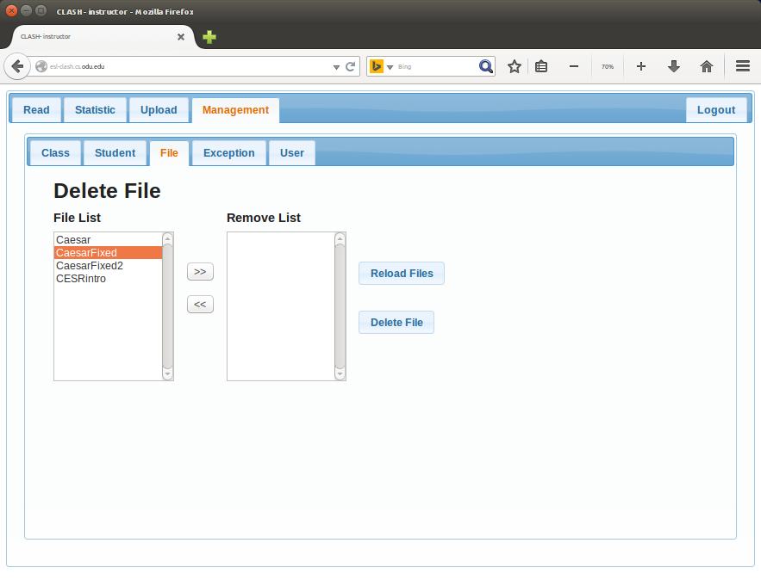
3. Click the “>>” button to add the document(s) to the Remove list.
4. Click the “Delete File” button.

### 

### 

### Exception List (Erich O’Saben)

---------------------------------------------------------------------------------------------------------------------

The Exception List contains words and phrases that qualify as Lexical Bundles, but do not follow the traditional rules of a Lexical Bundle. Each Instructor has the ability add items to their own exception list and when documents are processed by CESR, the items contained in the Exception List will be properly displayed as Lexical Bundles in the document reader.

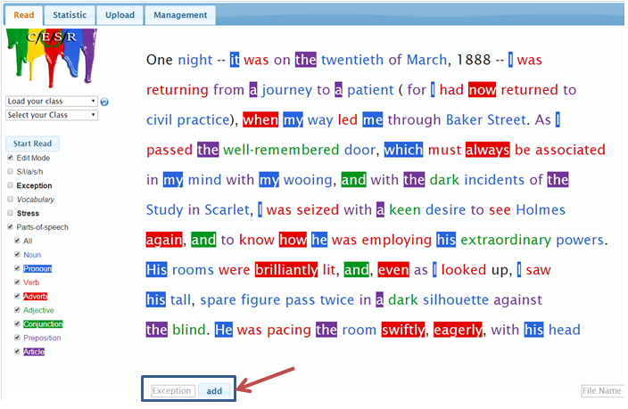

Now when the “Exception” item in the menu is toggled, the newly added phrase will be Slashed and Bolded.

### 

### 

### 

### 

### Managing the Exception List (Erich O’Saben)

---------------------------------------------------------------------------------------------------------------------

Viewing and Deleting items in the Exception List is also easy to accomplish in CESR. Under the Management tab in the Exception sub-tab, all of the previously added items to the Exception List are listed in the left side of the screen.

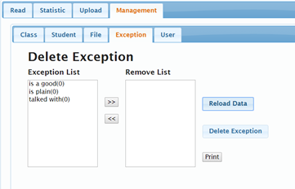

# 

To delete an item from the list, select an item from the list and click the  button and add the item to the right hand column and click  . Be aware that once an item has been deleted from the system, it is deleted forever and cannot be recovered, not even my an administrator.

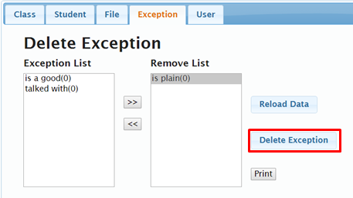

**Adding a Student User(Charles Stafford)**

-------------------------------------------------------------------------------------------------------------

Creating a new Student User is a very simple process. You click on the Management tab, and then on User.

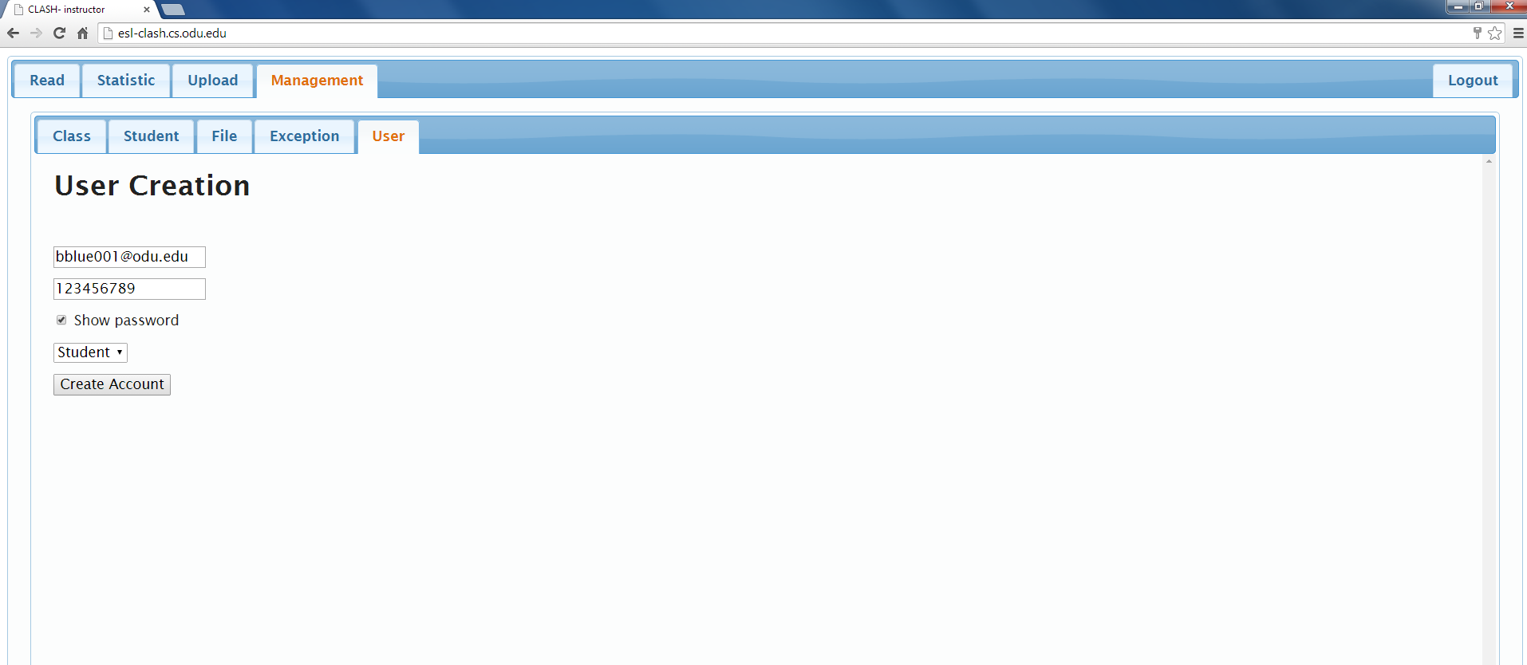

Type in the new Student’s Username and Password. The default Username should be the Student’s email. The default password for students is their University Identification Number. You will get get a message confirming the new user account.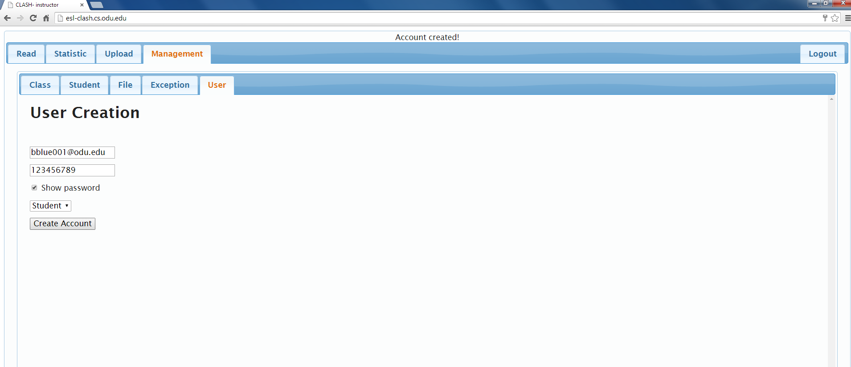

**View Enrollment List(Charles Stafford)**

--------------------------------------------------------------------------------------------------------------

To view the Enrollment list, you have to click on the Management Tab, and then click on Student. You will see a list of all the Classes, and all the Students in each Class.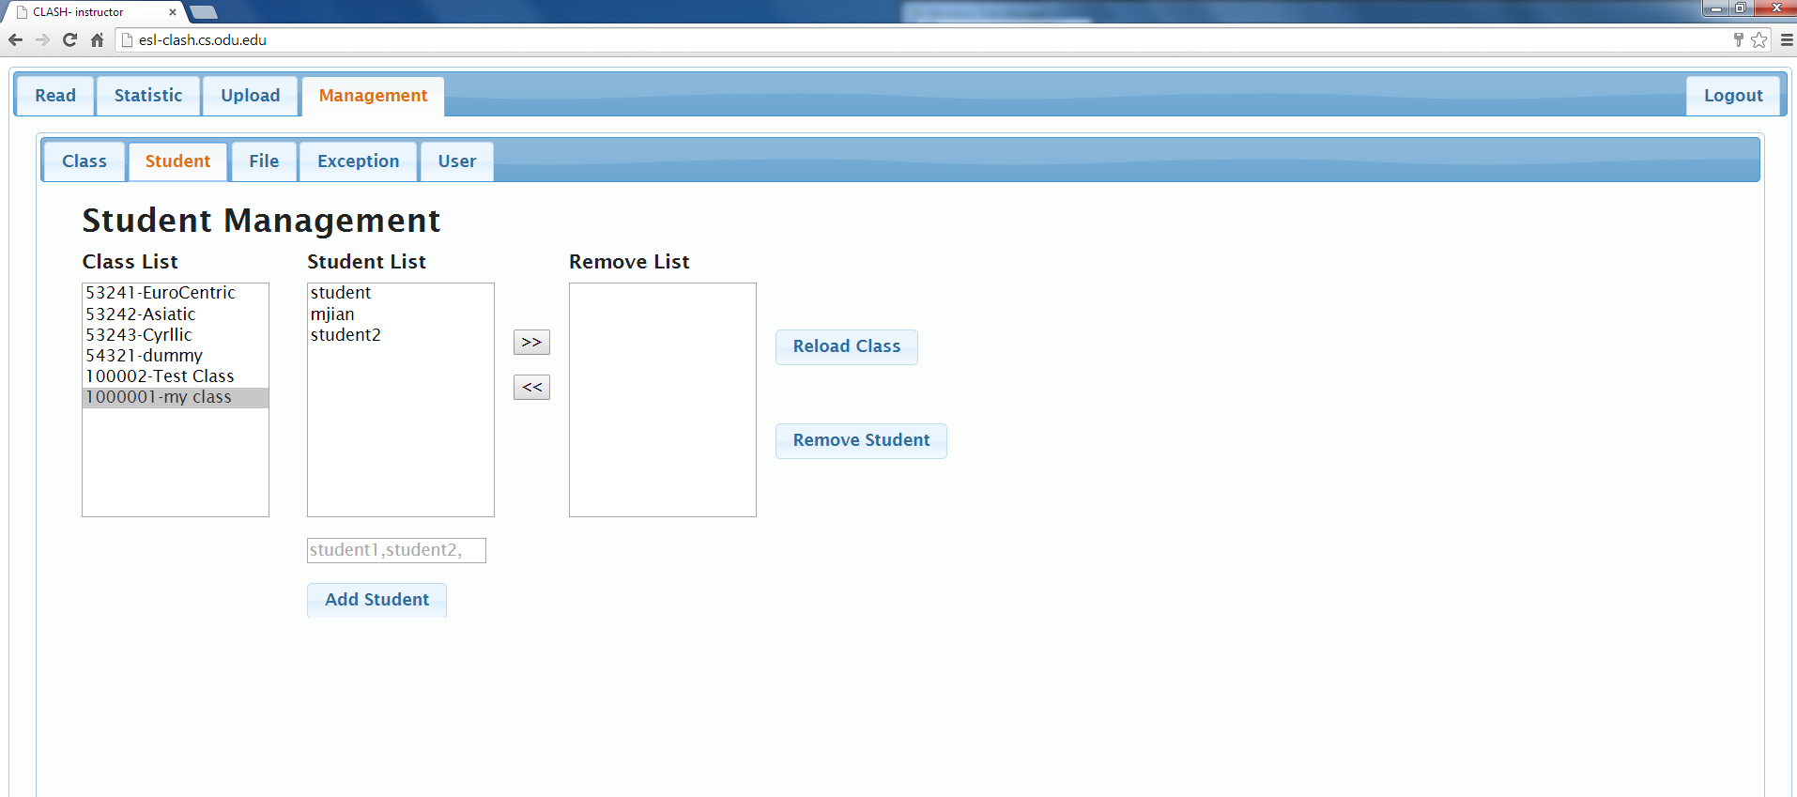

You can add students to classes, and remove students from classes, in this window.

**Removing a Student User(Fredrick Murry)**

------------------------------------------------------------------------------------------------------------

To remove a Student User, you must first click on the Management Tab, and then click on the Student Tab. From the Class List, select the Class in which the Student User is enrolled.



Then select the Student User from Student List.

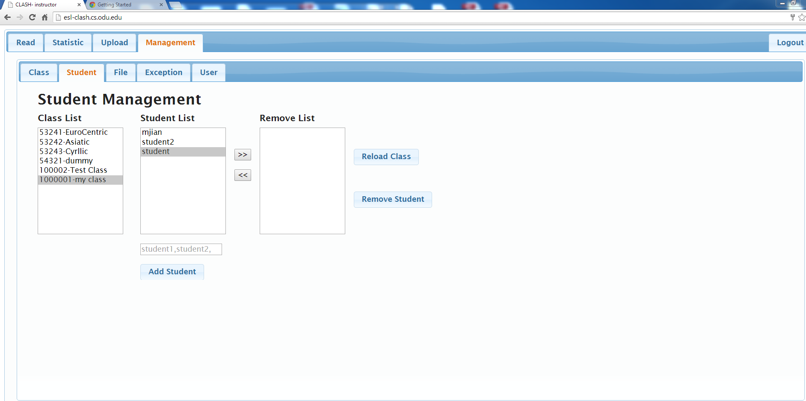

Click the “>>” button to move Student User to the Remove List. NOTE:If wrong Student User selected, “<<” button can be used to move Student User back to Student List.

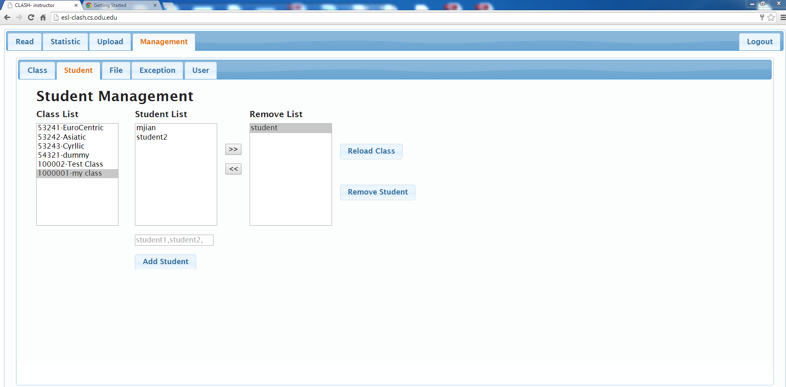

Click on the “Remove Student” button to remove Student User. Student User will be deleted from Remove List.

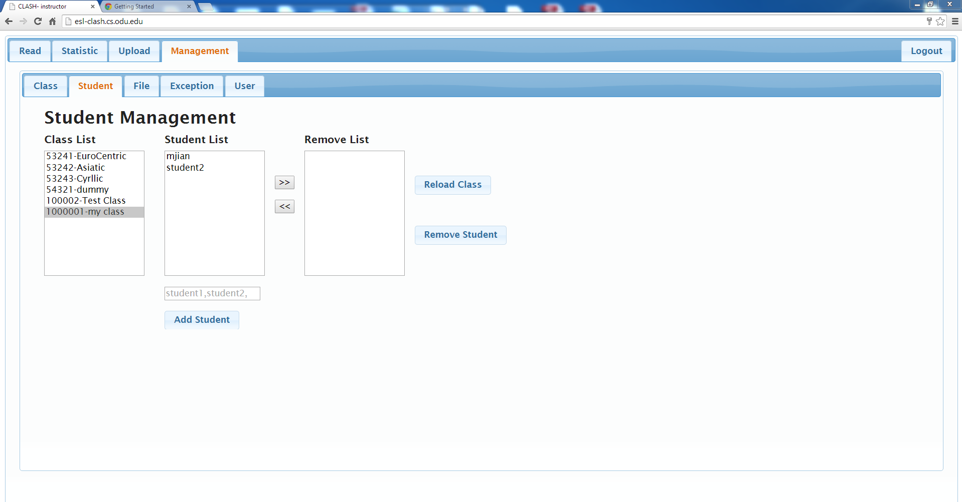

### Create Class (Justin Bennett)

--------------------------------------------------------------------------------------------------------------

Create a class group containing students that will share a common document set.

1. Select Class tab.

2. Enter Class Reference Number

3. Enter Class Name

4. Enter Instructors UserID

5. Push Create Class Button

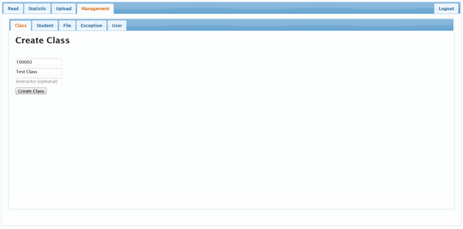

# Administrator

### Admin Log In (Francia Molina)

--------------------------------------------------------------------------------------------------------------

1. Type in the URL bar <http://esl-clash.cs.odu.edu/>

An example of the Login Page is shown in the figure below.



2. Type in username/password

An example of the Login Page with Username and Password

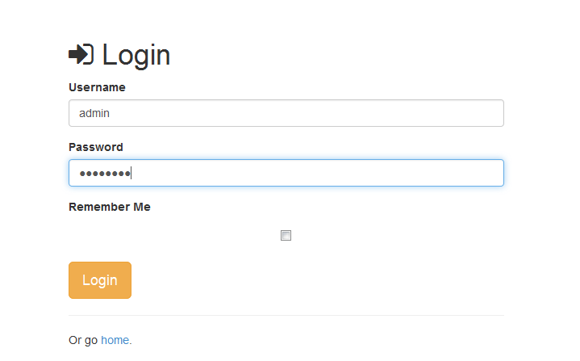

3. Click Login

1. Optional: Select checkbox “Remember Me”

An example of clicking “Login” button is shown in the figure below.

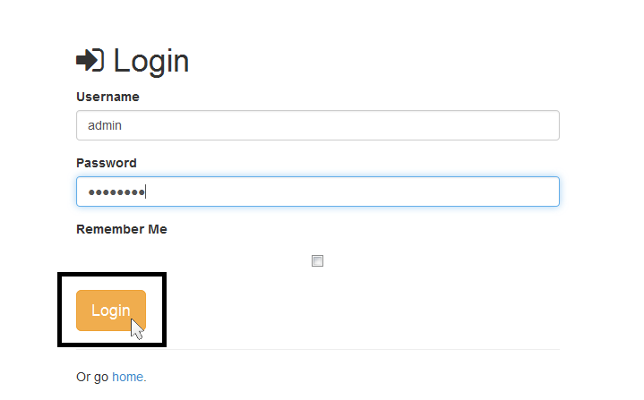

4. The “Administrator View” will load

An example of “Administrator View” is shown in the figure below.

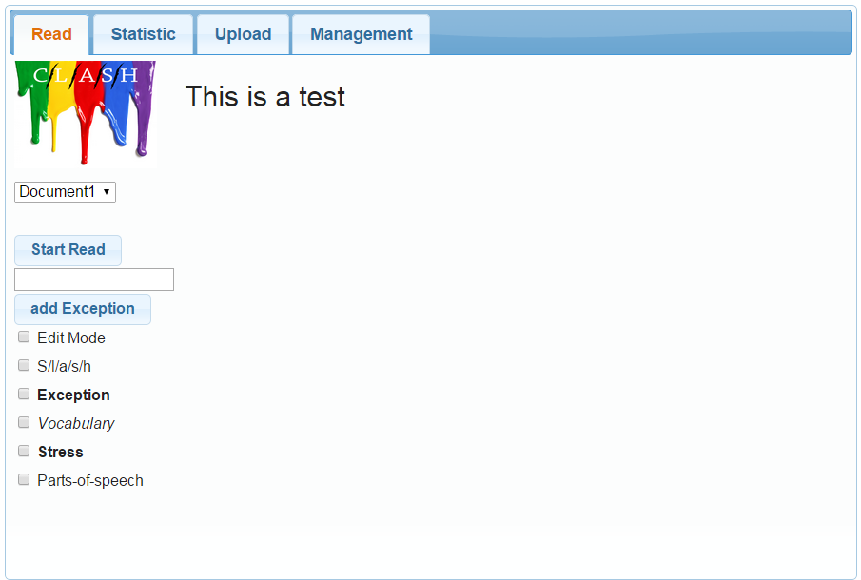

### Add Instructor User (Francia Molina)

--------------------------------------------------------------------------------------------------------------

5. Click on “Management” tab

An example of clicking on the “Management” tab is shown in the figure below.

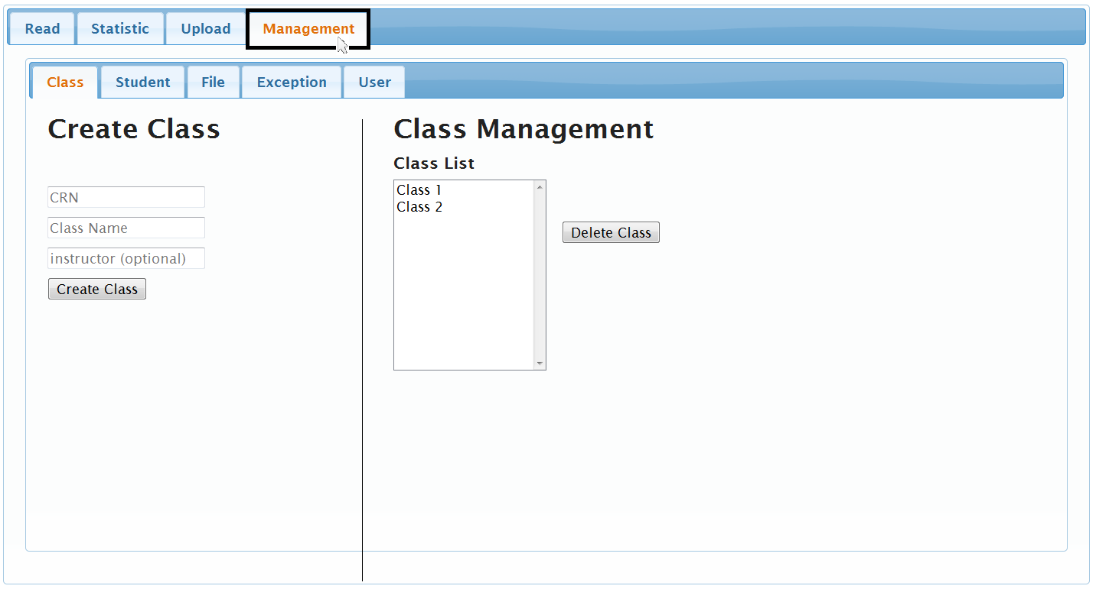

6. Click on “User” tab

An example of clicking on the “User” tab is shown in the figure below.

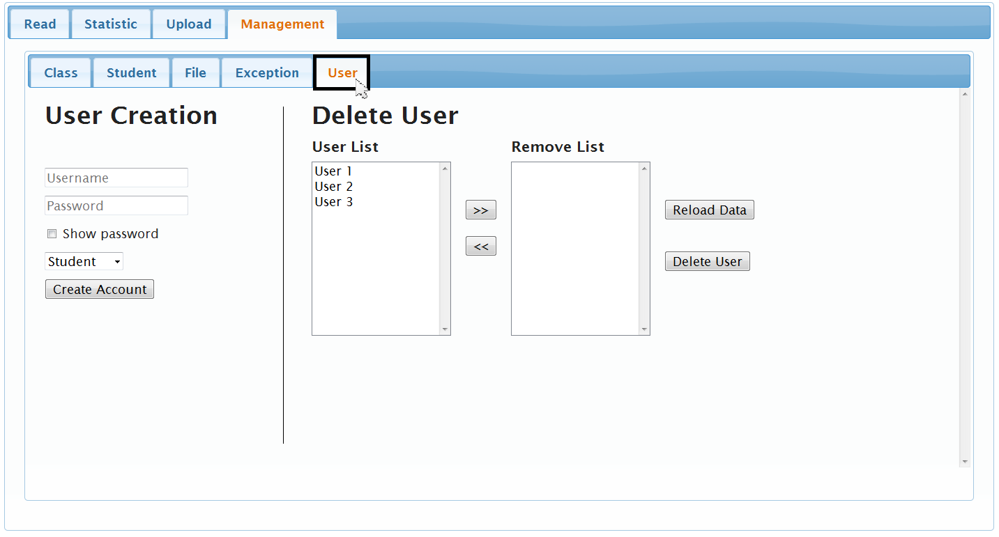

7. Under “User Creation”:

1. Enter a “Username”

Username needs to be a unique user name for the system. There is no limit on the number of characters or what type of characters that you can use with the username. This field is required when creating a user account.

An example of typing in “Username” is shown in the figure below.

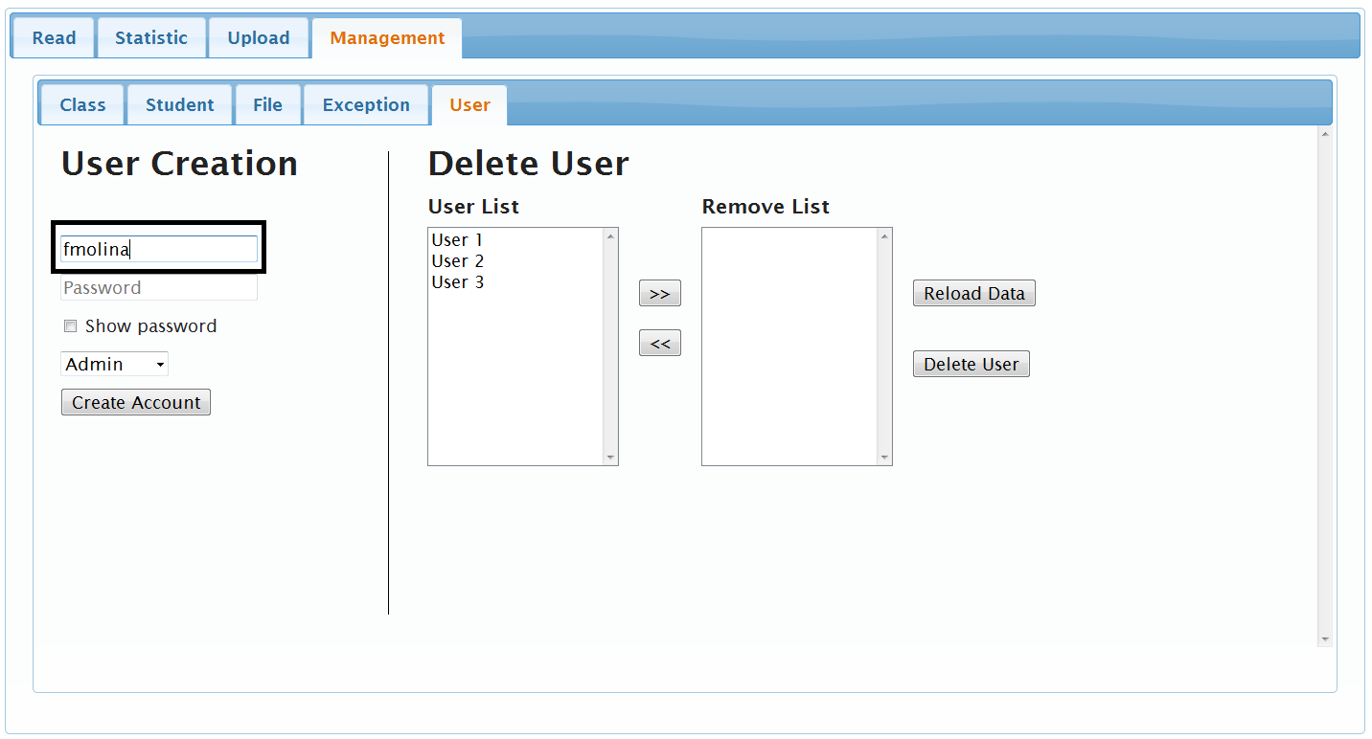

1. Enter a “Password”

There is no limit on the number of characters or what type of characters that you can use with the password. This field is required when creating a user account.

An example of typing in “Password” is shown in the figure below.

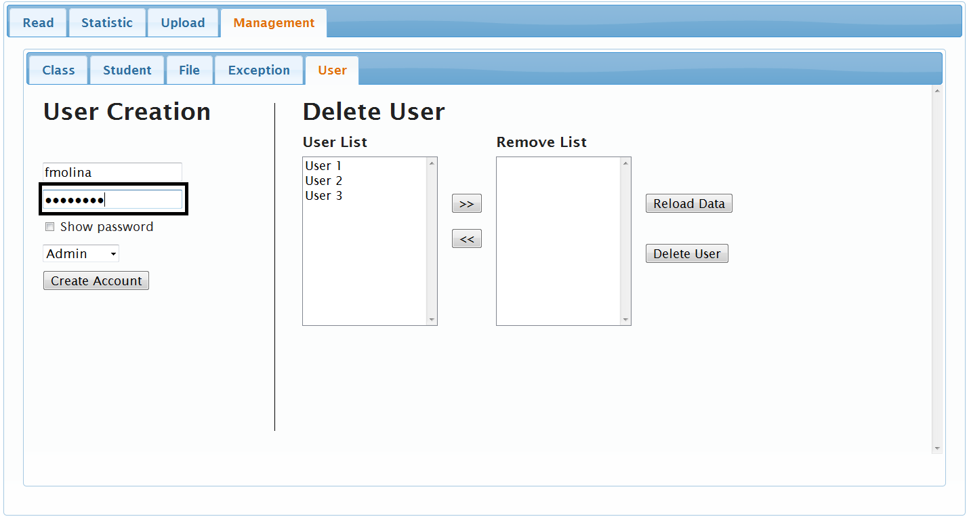

* Optional: Select “Show password” to display password

1. Select from Drop Down Menu, Instructor type of account.

An example of clicking on the “Instructor” account type is shown in the figure below.

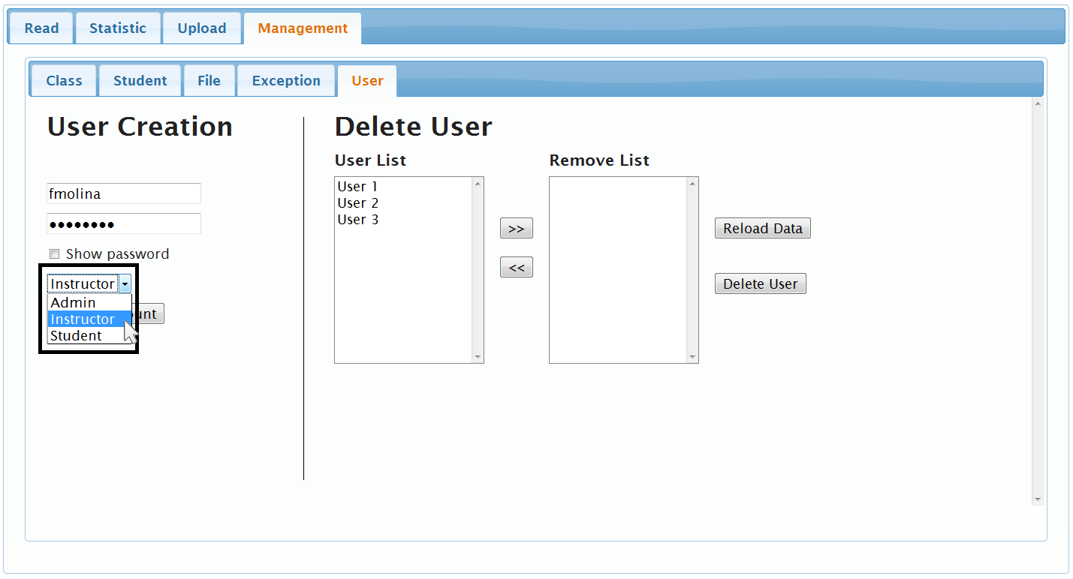

1. Click on “Create Account”

An example of clicking on the “Create Account” tab is shown in the figure below.

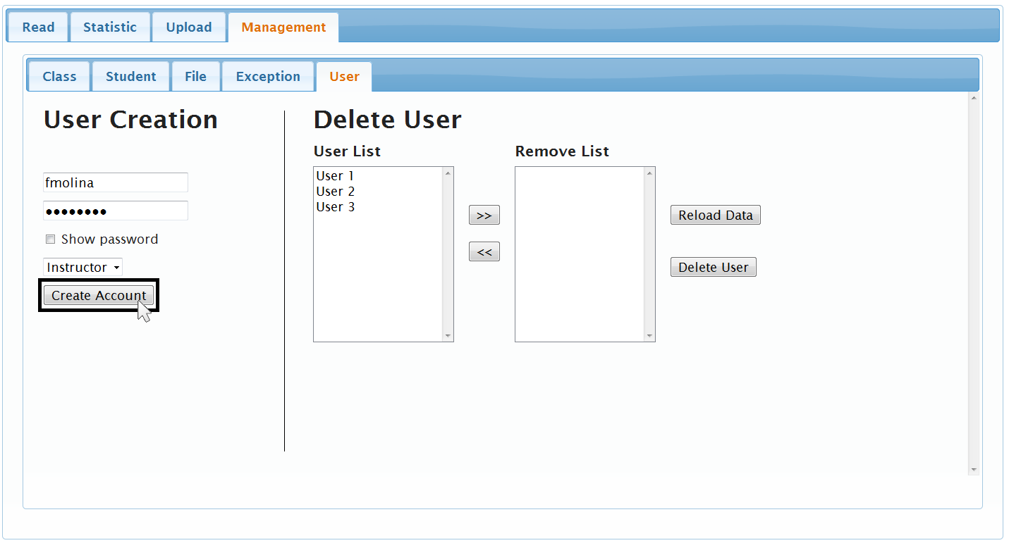

“THIS PART HAS BEEN LEFT INTENTIONALLY BLANK”

### Remove Instructor User (Francia Molina)

--------------------------------------------------------------------------------------------------------------

5. Under “Delete User”:

1. Under “User List”; Click desired “Username”

An example of clicking on a “Username” under the “User List” is shown in the figure below.

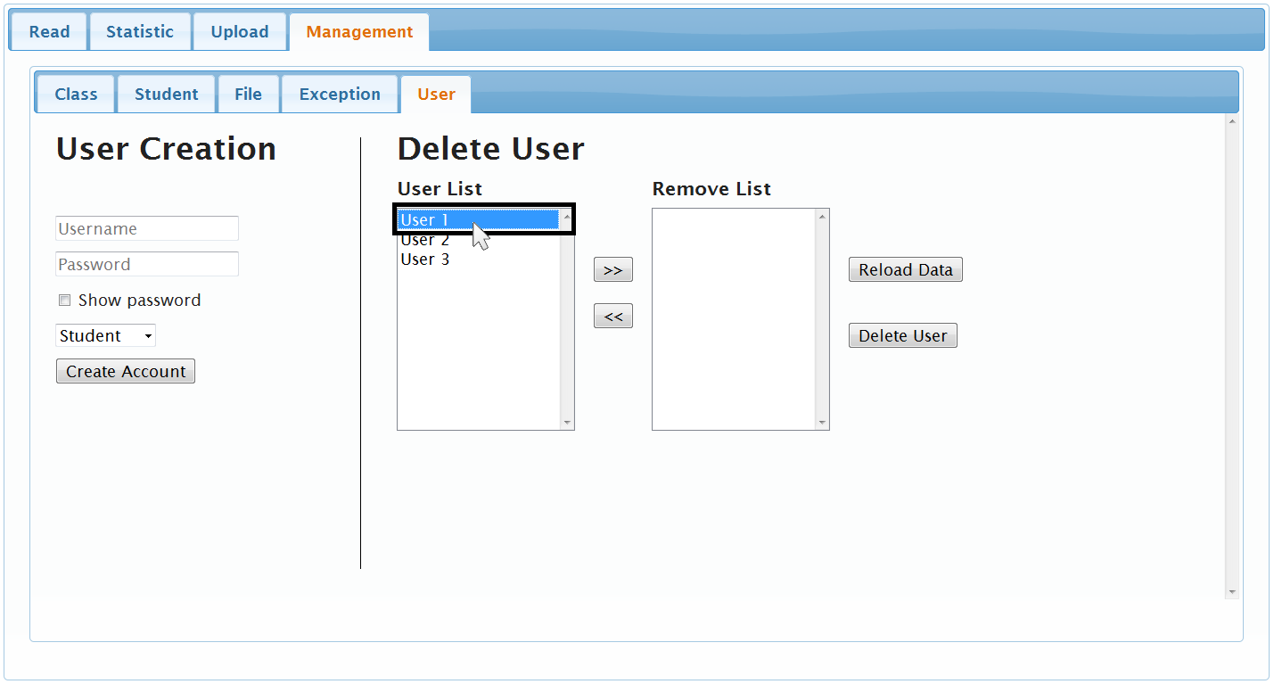

b. Click on the “>>” button

An example of clicking on “>>” is shown in the figure below.

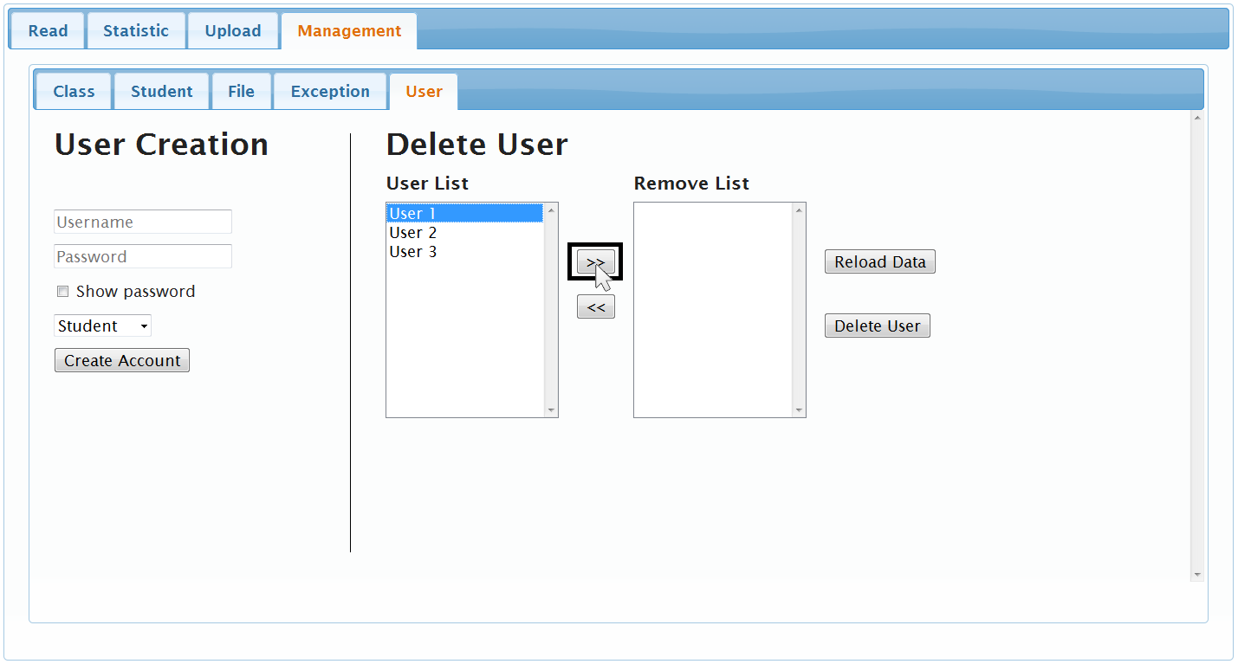

c. “Username” appears under “Remove List”

An example of “Username” highlighted is shown in the figure below.

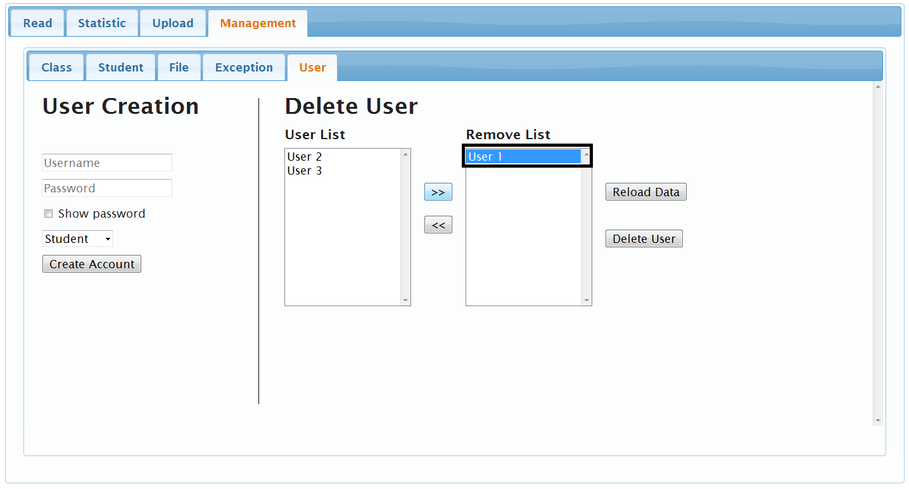

d. Click on “Delete User”

An example of clicking on “Delete User” highlighted is shown in the figure below.

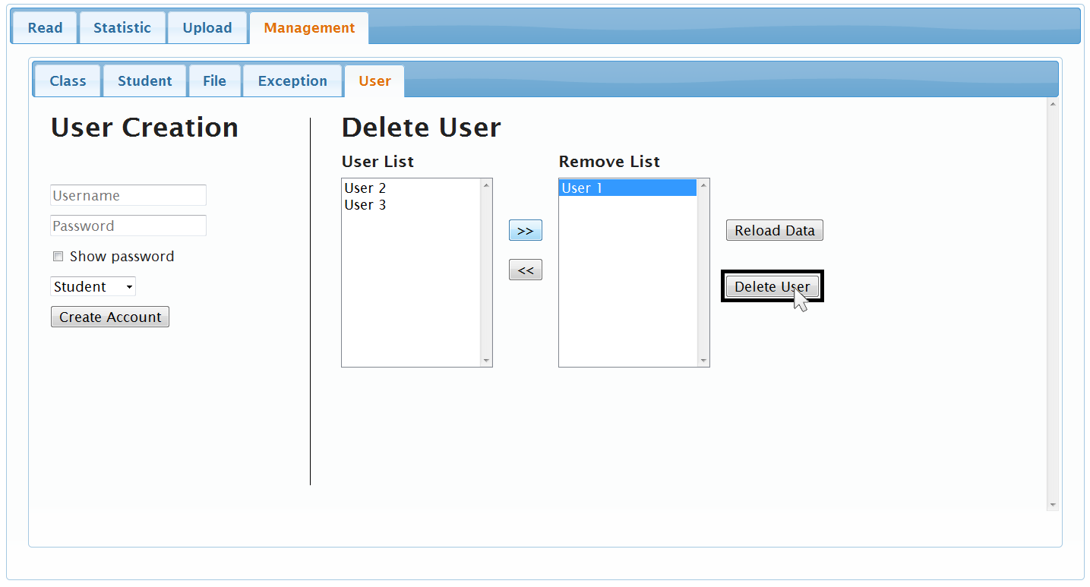

### View Instructor List (Francia Molina)

--------------------------------------------------------------------------------------------------------------

5. Click on “Management” tab

6. Click on “User” tab

7. Under “Delete User”:

1. Under “User List”; view all user names

An example of the “User List” view is shown in the figure below.

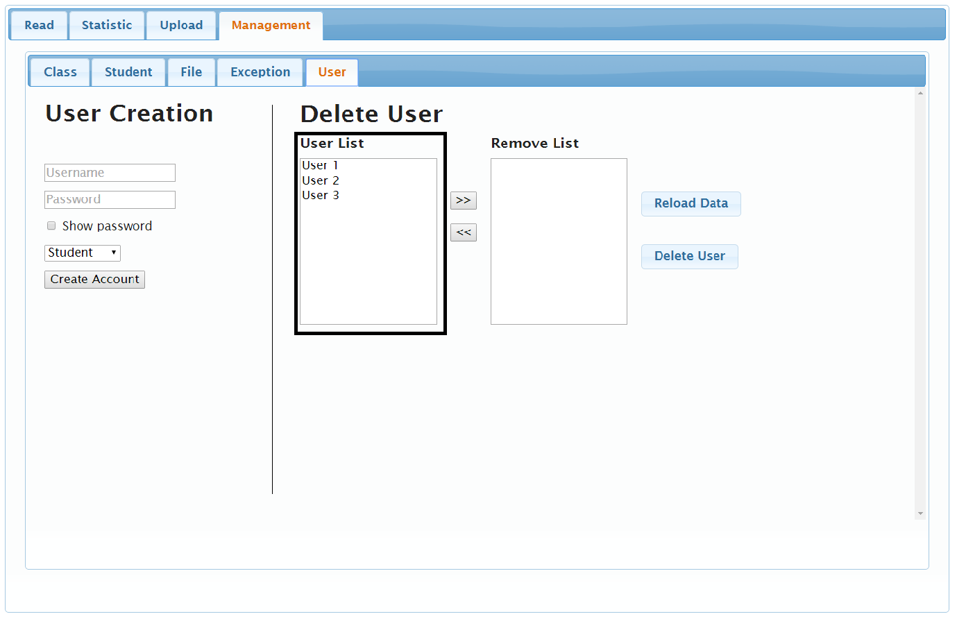

### 

### 

### 

### 

# 

# 

# Troubleshooting(Artem Fisan)

# 

**\*\*\*Make sure to use supported browser Google Chrome\*\*\***

**Problem: “I’m an ESL student and my password doesn’t work”**

Solution: Your UIN is Password, if you don’t remember your UIN please contact Registrar Office. If you still unable to log in please contact administrator for resolution.

Following message will appear for incorrect password entry:

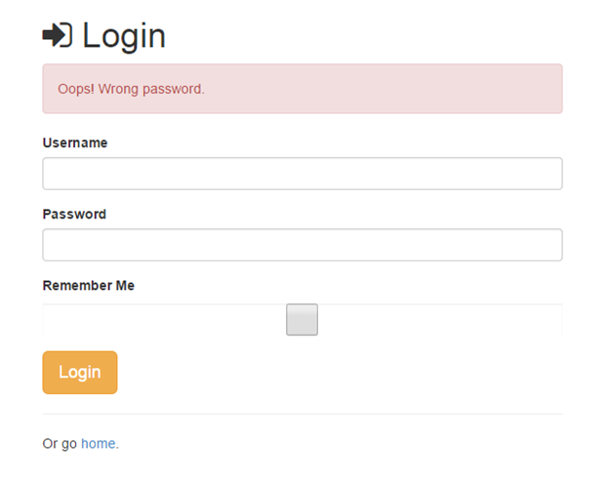

**Problem: “I forgot my user name…”**

Solution: The first part of your ODU email is your Username. If you do not know your Midas credentials please contact ITS Help Desk at 757-683-3189. If you still unable to log in please contact administrator for resolution.

If user enters wrong username following message will appear:

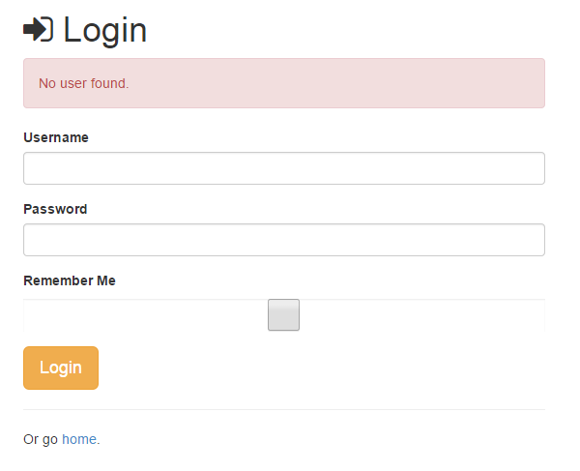

**Problem: “I’ve slash and colored my text but I work better when I read from paper. How can I print it?”**

PC Solution: Right Click on mouse, select “Print…” or Ctrl + P, select designated printer, and click “Print”

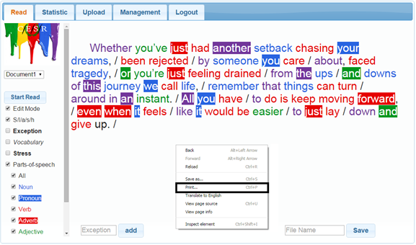

Mac Solution: Click “Control” + Trackpad, Command +P, select your printer, and click “Print”.

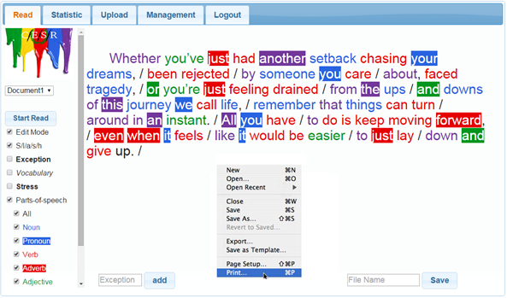

**Problem: “I have my document up but I do not see “colors”, what’s going on?”**

Solution: Once you are in the “Read” tab make sure to select “Parts-of-speech” check box; that will open up the POS menu.

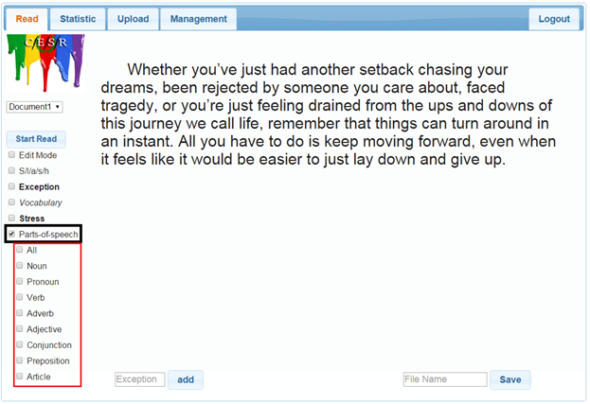

**Problem: “I’m trying to use Slash Handler but it’s not working…”**

Solution: Make sure to have a document or text entered first. It only works if there is text to process. Then, click on “ Start Read”.

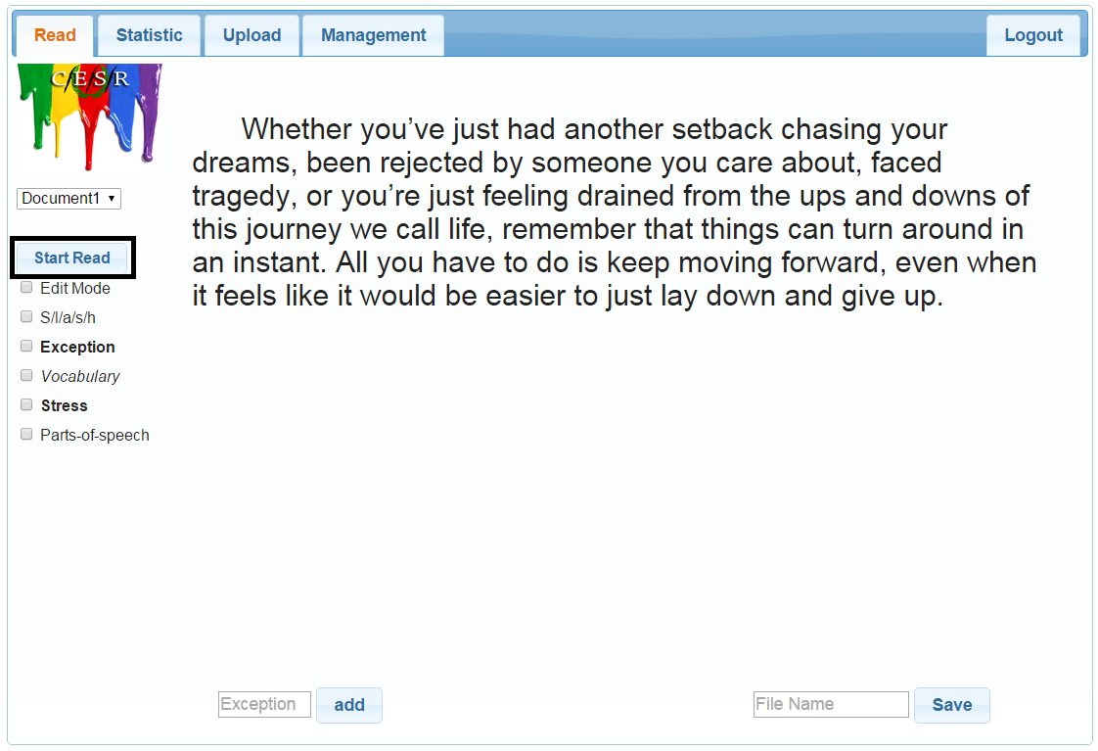

# Conclusion

### Log out (Mohammed Alabdullatif)

-------------------------------------------------------------------------------------------------------------

1-To logout click on  button

An example of Home Page is shown in the figure below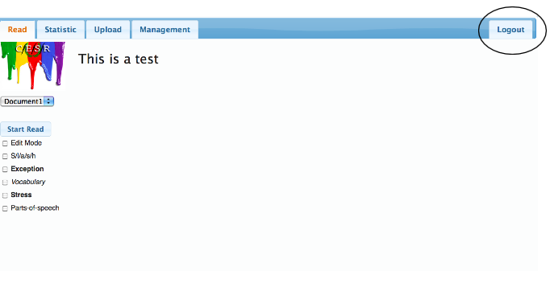

2-Now you are logged out from CESR

An example of the Login Page is shown in the figure below.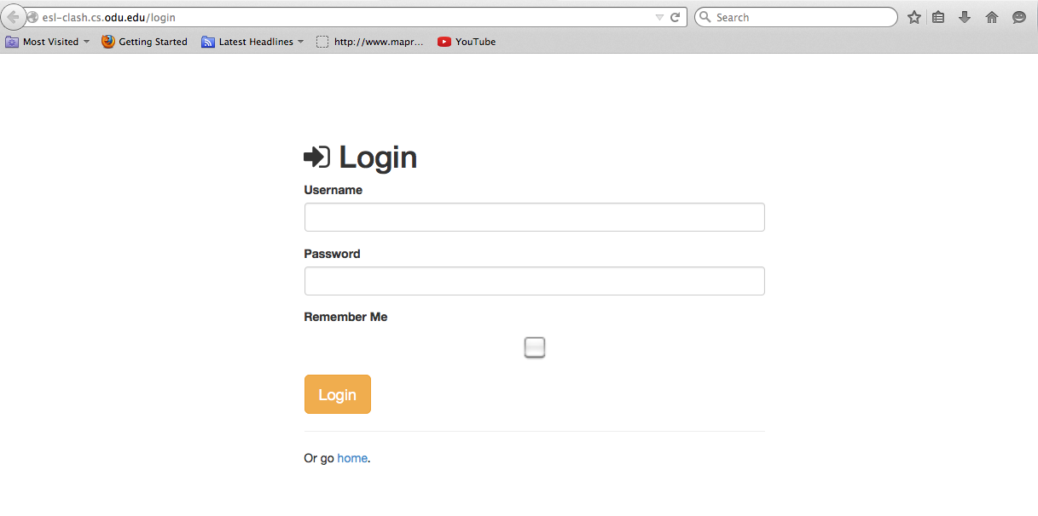

Thank you for using CESR, your journey has been completed. We hope that you have gained some knowledge to help you meet the needs of your English learning. If you have any questions don't hesitate to contact us.

# Contact Us

**Address: Attn: CESR ESL**

**℅ Greg Raver-Lampman**

**Old Dominion University, 1114 Dragas Hall**

**Norfolk, VA 23529**

**Phone: (757) 683-4424**

**Email: Greg Raver-Lampman:** [**graverla@odu.edu**](mailto:graverla@odu.edu)

**Subj: CESR ESL**